Order of the Mass

Weekday

Missa XVII (Advent and Lent)

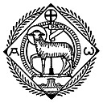

Extraordinary Form

This booklet was prepared for parish use (January 2015)

Excerpts from the English translation of The Roman Missal © 2010, International Commission on English in the Liturgy Corporation (ICEL). All rights reserved. This hymnal may be reproduced. It should not be sold for profit; it may only sold for the cost of production. Refer to ICEL copyright policies (www.icelweb.org).

Music and English translation of hymns from Parish Book of Chant (editor Richard Rice) © 2012 used with permission from The Church Music Association of America.

Booklet from http://gregorian-chant-hymns.com/publications/

As the bell rings, all stand for the Entrance Procession during which the choir sings the Introit.

Introit Text in handout

All kneel as the servers kneel and the priest begins the prayers at the foot of the altar which are our preparation for worship and our request for God’s forgiveness.

All rise as the priest ascends to the altar and incenses it. Remain standing to sing the Kyrie and the Gloria, alternating with the schola, as indicated.

Choir and congregation alternate

Choir begins:

Pr. Lord, have mercy. R. Lord, have mercy.
Pr. Christ, have mercy. R. Christ, have mercy.
Pr. Lord, have mercy. R. Lord, have mercy.

---------------
ij : Latin numeration for twice. Sing the section twice.
iij : Latin numeration for three times.
GLORIA *

* May be omitted Choir and congregation alternate

Priest: Choir:

All: Choir:

Glory to God in the highest,
and on earth peace to people of good will.

We praise you,
we bless you,
we adore you,
we glorify you, we give you thanks for your great glory,
Lord God, heavenly King,
O God, almighty Father.

Lord Jesus Christ, Only Begotten Son,
Lord God, Lamb of God, Son of the Father,
you take away the sins of the world, have mercy on us;
you take away the sins of the world, receive our prayer;
you are seated at the right hand of the Father, have mercy on us.
For you alone are the Holy One,
you alone are the Lord,
you alone are the Most High,
Jesus Christ,
with the Holy Spirit, in the glory of God the Father. Amen.

Priest: The Lord be with you. All: And with your spirit.

COLLECT Text in handout

After the Collect, all sit.

EPISTLE Text in handout

Gradual Text in handout

ALLELUIA or TRACT Text in handout

All stand for the singing of the gospel.

GOSPEL Text in handout

Priest: The Lord be with you. All: And with your spirit.
Priest: The continuation (or beginning) of the holy Gospel according to N.
All: Glory to you, O Lord.

HOMILY


All stand for the Creed.
(If the Creed is not sung, turn to page 10)

CREED

Choir and congregation alternate

Priest: Choir:

All:

Kneel

Stand

I believe in one God,
the Father almighty,
maker of heaven and earth,
of all things visible and invisible.

I believe in one Lord Jesus Christ,
the Only Begotten Son of God,
born of the Father before all ages.
God from God, Light from Light,
true God from true God,
begotten, not made, consubstantial with the Father;
through him all things were made.
For us men and for our salvation
he came down from heaven,

[At the words that follow, up to and including “and became man,” all bow.]

and by the Holy Spirit was incarnate of the Virgin Mary,
and became man.

For our sake he was crucified under Pontius Pilate,
he suffered death and was buried,
and rose again on the third day
in accordance with the Scriptures.
He ascended into heaven
and is seated at the right hand of the Father.
He will come again in glory
to judge the living and the dead
and his kingdom will have no end.

I believe in the Holy Spirit, the Lord, the giver of life,
who proceeds from the Father and the Son,
who with the Father and the Son is adored and glorified,
who has spoken through the prophets.
I believe in one, holy, catholic and apostolic Church.
I confess one Baptism for the forgiveness of sins
and I look forward to the resurrection of the dead
and the life of the world to come. Amen.

Priest: Dóminus vobíscum All: Et cum spíritu tuo.
The Lord be with you. And with your spirit.

Remain standing until the priest reads the offertory verse.
All sit for the offertory.

OFFERTORY Text in handout

SECRET Text in handout

Priest. Per ómnia sæcula sæculórum. All: Amen
World without end. Amen

All stand when the congregation is sensed.

PREFACE

Pr. The Lord be with you.
R. And with your spirit.
Pr: Lift up your hearts.
R.: We lift them up to the Lord.
Pr. Let us give thanks to the Lord our God.
R. It is right and just.

All kneel. SANCTUS

Choir: * All:

Holy, Holy, Holy, Lord God of hosts.
Heaven and earth are full of your glory.
Hosanna in the highest.
Blessed is he who comes in the name of the Lord.
Hosanna in the highest.

All remain kneeling for the Canon (the Eucharistic Prayer). This prayer is said silently.

CANON

Final Doxology of the Canon and Minor Elevation:

Priest. Per ómnia sæcula sæculórum. All: Amen
World without end. Amen

All stand for the Lord’s Prayer which is sung by the priest alone.

All:

But deliver us from evil.

The priest says in secret the Libera nos (Deliver us …), followed by the fraction of the Host.

Priest. Per ómnia sæcula sæculórum. All: Amen
World without end. Amen

Priest: Pax Dómini sit semper vobis cum.
May the peace of the Lord be always with you.

All: Et cum spíritu tuo.
And with you spirit.

All kneel in preparation for Holy Communion.

AGNUS DEI

Choir sings each “Agnus Dei”
All complete the phrase after asterisk (*)

Choir: * All:

Lamb of God, you take away the sins of the world, have mercy on us.
Lamb of God, you take away the sins of the world, have mercy on us.
Lamb of God, you take away the sins of the world, grant us peace.

PRAYERS AT THE COMMUNION

Priest: Ecce Agnus Dei, ecce qui tollit peccáta mundi. |  | Behold the Lamb of God, behold Him who takes away the sins of the world.

All who will receive Communion, say three times:

Dómine, non sum dignus, ut intres sub tectum meum, sed tantum dic verbo, et sanábitur ánima mea. |  | Lord, I am not worthy that you should enter under my roof, but only say the word and my soul shall be healed.
As the priest receives Holy Communion, those who are to receive Holy Communion should come forward and kneel at the communion rail. Holy Communion may only be received on the tongue at this Mass. The priest says the entire formula and the communicant does not respond “Amen.”

COMMUNION VERSE Text in handout

All stand

Priest: Dóminus vobíscum All: Et cum spíritu tuo.
The Lord be with you. And with your spirit.

Priest: Orémus.
Let us pray.

POSTCOMMUNION PRAYER Text in handout

Priest: (Recites prayer) All: Amen

THE DISMISSAL

Priest: Dóminus vobíscum All: Et cum spíritu tuo.
The Lord be with you. And with your spirit.

All:

Go forth, the Mass is ended. Thanks be to God.

All kneel for the Blessing.

FINAL BLESSING

Priest: … Pater, et Filius, et Spíritus Sanctus. All: Amen
… Father, Son, and Holy Spirit. Amen
All stand for the reading of the last gospel (the prologue from the Gospel of St. John).

LAST GOSPEL

Priest: Dóminus vobíscum.  S: Et cum spíritu tuo.  Priest: 􏰀Inítium sancti Evangélii secúndum Joánnem.  S: Glória tibi, Dómine.  Priest: In princípio erat Verbum, et Verbum erat apud Deum, et Deus erat Verbum. Hoc erat in princípio apud Deum. Omnia per ipsum facta sunt: et sine ipso factum est nihil, quod fac-tum est: in ipso vita erat, et vita erat lux hóminum: et lux in ténebris lucet, et ténebræ eam non comprehendérunt.  Fuit homo missus a Deo, cui nomen erat Joánnes. Hic venit in testimónium, ut testimónium perhibéret de lúmine, ut omnes créderent per illum. Non erat ille lux, sed ut testimónium per-hibéret de lúmine. Erat lux vera, quæ illúminat omnem hóminem veniéntem in hunc mundum.  In mundo erat, et mundus per ipsum factus est, et mundus eum non cognóvit. In própria venit, et sui eum non recepé-runt. Quotquot autem recepé-runt eum, dedit eis potestátem fílios Dei fíeri, his qui credunt in nómine ejus: qui non ex sanguínibus, neque ex voluntáte carnis, neque ex voluntáte viri, sed ex Deo nati sunt.  [Genuflect]  ET VERBUM CARO FACTUM EST, et habitávit in nobis: et vídimus glóriam ejus, glóriam quasi Unigéniti a Patre, plenum grátiæ et veritátis.  S. Deo grátias. |  | The Lord be with you.  And with thy spirit.  The beginning of the Gospel according to Saint John.  Glory be to Thee, O Lord.  In the beginning was the Word, and the Word was with God, and  the Word was God. The same was in the beginning with God. All  things were made by Him: and without Him was made nothing that was made: in Him was life, and the life was the Light of men: and the Light shineth in darkness, and the darkness did not com-prehend it.  There was a man sent from God, whose name was John. This man came for a witness, to bear wi-tness of the Light, that all men might believe through Him. He was not the Light, but was to bear witness of the Light. That was the true Light, which enligh-teneth every man that cometh into this world.  He was in the world, and the world was made by Him, and the world knew Him not. He came unto His own, and His own  received Him not. But as many as received Him, to them He gave power to become the sons of God, to them that believe in His name: who are born, not of blood, nor of the will of the flesh, nor of the will of man, but of God.  AND THE WORD WAS MADE FLESH, and dwelt among us: and we saw His glory, the glory as of the Only- begotten of the Father, full of grace and truth.  S. Thanks be to God.

FINAL ANTIPHONS TO OUR LADY

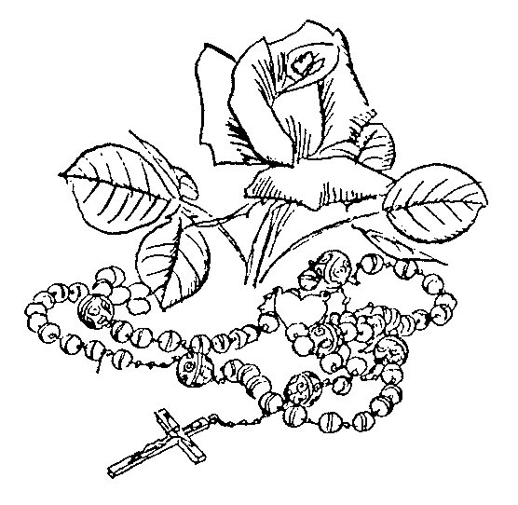

Alma Redemptoris Mater: Advent – 2 February pg 17
Ave, Regina caelorum: 3 February – Holy Week pg 18

ALMA REDEMPTORIS MATER
Advent - 2 February

Holy Mother of our Redeemer, thou gate leading to heaven and star of the sea; help the falling people who seek to rise, thou who, all nature wondering, didst give birth to thy holy Creator. Virgin always, hearing that Ave from Gabriel’s lips, take pity on us sinners.

AVE, REGINA CAELORUM
3 February - Holy Week

Hail, Queen of heaven, hail Lady of the angels. Hail root and gate from which the Light of the world was born. Rejoice glorious Virgin, fairest of all. Fare thee well, most beautiful, and pray for us to Christ.

HYMNS

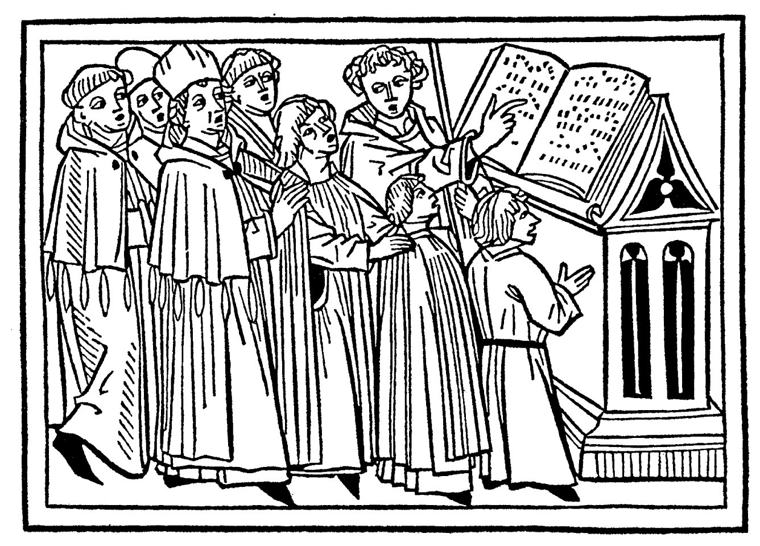

Adoremus in aeternum 20  Adoro te devote 21  Anima Christi . 25  Attende Domine 46  Ave Maria 32  Ave maris stella 33  Ave verum Corpus 26  Creator alme 36 | Ecce panis Angelorum 30  Jesu Dulcis memoria 28  Miserere et parce 41  Panis angelicus 27  Parce Domine 48  Rorate caeli 38  Vexilla Regis 51
General ADOREMUS IN AETERNUM

General

Let us worship forever the most holy Sacrament. Ps. O praise the Lord, all ye nations: praise Him, all ye people. For His mercy is confirmed upon us: and the truth of the Lord remaineth for ever. Glory be to the Father, and to the Son, and to the Holy Spirit: as it was in the beginning, is now, and ever shall be, world without end. Amen.

ADORO TE DEVOTE

Hymn of St. Thomas Aquinas

Humbly I adore Thee, hidden Godhead, veiled truly under these figures. All my heart I give to Thee, for it all fails in contemplating Thee.

General

Sight, touch and taste tell me nothing of Thy presence; yet safely I trust what I hear. I believe whatever the Son of God has said; nothing can be more true than the word of Truth itself.

On the cross Thy Godhead was hidden; here is hidden Thy manhood too. Yet, I believe and confess both, praying as prayed the good thief.

General

I do not see Thy wounds like Thomas, yet I confess Thee my God. Grant that I may ever more and more believe in Thee, hope in Thee, love Thee.

O memorial of the death of the Lord, living Bread, giving life to man, let me ever live of Thee, ever sweetly taste Thee.

General

Pious pelican, Jesus Lord, cleanse me, the unclean, by Thy blood, of which one drop is enough to wash the world of all sin.

Jesus, Whom now I see veiled, I pray that this may come for which I long so much: that at last, seeing Thee face to face, I may be blessed by the sight of Thy glory. Amen.

ANIMA CHRISTI General

General

Soul of Christ, sanctify me: Body of Christ, save me. 2. Blood of Christ, inebriate me: water from the side of Christ, wash me. 3. Passion of Christ, comfort me: O good Jesus, hear me. 4. Within Thy wounds hide me: nor permit me to be separated from Thee. 5. From the foe malign defend me: in the hour of my death call me. 6. And bid me come to Thee: that with Thy Saints I may praise Thee world without end. Amen.

AVE VERUM CORPUS

Hail, true Body, born of Mary the Virgin; truly suffering, sacrificed on the cross for man; from Whose pierced side flowed water and blood. Be to us a foretaste at death’s trial, O sweet Jesus, O loving Jesus, O Jesus Son of Mary.

PANIS ANGELICUS General

The angelic bread becomes the bread of men; the celestial bread puts an end to figures; O wondrous thing! The poor, the slave and the humble one eats the Lord.

You, Deity triune and one, we urgently ask: thus [please] visit us, as we worship you; along your paths lead us to where we long [to be], to the light which you inhabit.

General JESU DULCIS MEMORIA
In Honour of the Holy Name of Jesus

How sweet the memory of Jesus, giving joy to true hearts; but beyond honey and all else, is the sweetness of His presence.

Nothing is sung more agreeably, nothing heard more delightfully, nothing thought more sweetly, than Jesus the Son of God.

General

Jesus, hope of penitents, how kind to those who beg, how good to those who seek: but what art Thou to those who find Thee!

Tongue cannot speak, pen cannot write; experience alone can believe, what it is to love Jesus.

Be thou, O Jesus, our joy, Who shall be our future reward: may our glory be in Thee, through everlasting ages.

Vespers Hymn for Feast of the Holy Name of Jesus
Lauds Hymn for Feast of Transfiguration

General ECCE PANIS ANGELORUM

1. | Behold the Bread of Angels, become the food of the pilgrims: truly the bread of the sons, which cannot be thrown to the dogs.
2. | It is pre-signified in types, when Isaac is brought to be sacrificed, the Paschal lamb is chosen, manna is given to the fathers.

General

3. | Good shepherd, true bread, Jesus, have mercy on us: feed us, protect us, make us see good things in the land of the living.
4. | You Who know and can do all things, You who feed us mortals here, make us there your table companions, coheirs and comrades of the holy citizens.

Note: Ecce panis Angelorum is taken from the last four verses, but not intended as an abbreviated version of "Lauda Sion" (Corpus Christi Sequence).

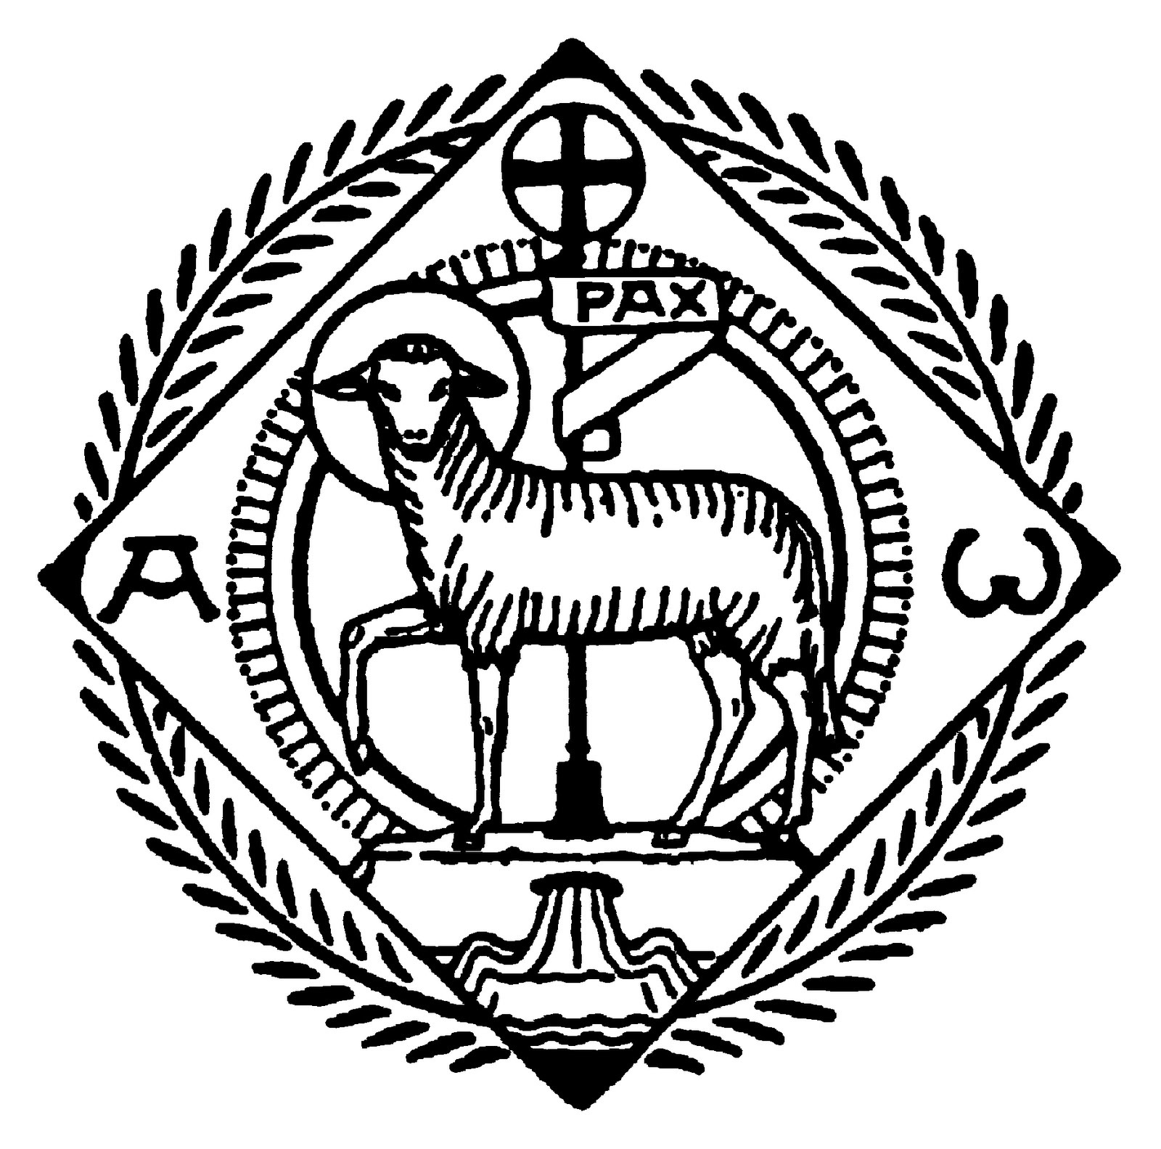
The Blessed Virgin AVE MARIA

Hail Mary, full of grace! the Lord is with thee; blessed art thou among women, and blessed is the fruit of thy womb, Jesus. Holy Mary, Mother of God, pray for us sinners, now and at the hour of our death. Amen.

AVE MARIS STELLA The Blessed Virgin

Hail, star of the sea, kindly Mother of God and ever Virgin, happy gate of heaven.

Receiving that ‘Ave’ from the mouth of Gabriel, establish us in peace, changing the name of ‘Eva’ [Eve]. .

Loosen the chains of the guilty, bring light to the blind, dispel our evils, obtain for us all good things.
The Blessed Virgin

Show thyself a Mother: may he who, being born for us, was willing to be thine, receive [our] prayers through thee.

O singular Virgin, meek above all others, make us free from fault, meek and chaste.

Bestow a pure life, prepare a safe path, that seeing Jesus we may rejoice for ever.
The Blessed Virgin

Be praise to God the Father, glory to the Most High Christ [and] to the Holy Spirit, one honor to the Three.

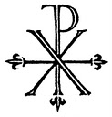
Advent CREATOR ALME SIDERUM

Propitious Creator of the stars, eternal light of believers, Jesus, Redeemer of all, hearken to the prayers of suppliants.

Who, lest the world should perish through deceits of demons, urged by the vigor of love, becamest the healing of a sickly world.

Who, to expiate the common sin of the world, camest forth a spotless victim from the sanctuary of the Virgin.

Advent

When the power of whose glory and whose name is first sounded, the inhabitants both of heaven and hell are bent on trembling knee.

We beseech thee, Great Judge of the last day, defend us from our enemies with arms of grace from above.

Power, honor, praise, glory to God the Father with the Son, together with the Holy Paraclete, unto ages of ages.

Advent RORATE CAELI

Refrain:

Drop down dew, ye heavens, from above,
and let the clouds rain down the Just One.

Verses:

Be not angry, O Lord, and remember no longer our iniquity: behold the city of the Holy One is become a desert: Sion is become a desert: Jerusalem is desolate: the house of Thy sanctification and of Thy glory, where our fathers praised Thee.

Advent

We have sinned and are become as one that is unclean: and we have all fallen as a leaf, and our iniquities like the wind have carried us away: Thou hast hidden Thy face from us, and hast crushed us in the hold of our iniquity.

Advent

Behold, O Lord, the affliction of Thy people, and send forth Him Who is to come: send forth the Lamb, the ruler of the earth, from the Rock of the desert, to the mount of the daughter of Sion: that He may take away the yoke of our captivity.

Be comforted, be comforted, my people: thy salvation cometh quickly: why art thou consumed with grief: for sorrow hath estranged thee: I will save thee: fear not, for I am the Lord thy God, the Holy One of Israel, thy Redeemer.

MISERERE ET PARCE Lent

Refrain:

Have mercy, and spare your people, O most merciful Lord:
For we have sinned against You.

Repeat Refrain: Misérere.

Verses:

Prostrate, we all weep laying open to You the secret sins we have committed, we beg forgiveness from You, O God.
For we have sinned against You.

Lent

Receive the priests’ prayers, and whatever they ask, abundantly grant; and have mercy on your people, O Lord.
For we have sinned against You.

You have brought your wrath upon us; our sins have grievously bent us over, and we languish, with all hope gone.
For we have sinned against You.

Lent

We have been given over to unimaginable evils, and every evil has flooded over us, and we have called out, and heard nothing.
For we have sinned against you.

We all cry out, we all implore You, penitent, we turn to You with tears, to you whose wrath we have ourselves provoked.
For we have sinned against You.

Beseeching you, sighing we ask of you; O Jesus Christ, prostrate we pray You: may your power come to the aid of us wretches.
For we have sinned against You.
Lent

Receive the confession of your people, which we pour out before You as we mourn, and in our heart we groan for our sins.
For we have sinned against you.

We ask for peace; grant us peace; take away wars, and deliver us all: we ask You, O Lord, with humble prayer.
For we have sinned against You.

Lent

Incline your ear, O God most merciful; now let the stains of our sins be washed away and in kindness free us from perils.
For we have sinned against You.

Refrain:

Have mercy, and spare your people, O most merciful Lord:
For we have sinned against You.

Lent ATTENDE DOMINE

Refrain:

Look down, O Lord, and have mercy, for we have sinned against thee.

Verses:

To thee, high King, Redeemer of all, weeping we lift our eyes; hear, Christ, the prayers of thy servants.

Lent

Right hand of the Father, cornerstone, path of salvation and gate of heaven, cleanse the stain of our sins.

O God, we pray thy majesty, lend thy holy ears to our sighs, mercifully forgive our offenses.

To thee we confess committed sin, with contrite heart we unveil hidden faults; may thy mercy, Redeemer, forgive.

Lent

Seized though innocent, led away unresisting, condemned by false witness in place of the guilty, Christ keep those whom thou hast saved.

PARCE DOMINE

Refrain:

Spare, O Lord, spare Thy people, lest Thou be angry with us forever.

Lent
Verses:

Let us bow down before the avenging wrath; let us weep before the Judge; let us cry forth in prayer of supplication, and all fall prostrate in prayer.

By our sins we have offended Thy clemency, O God; pour out on us thy pardon from on high, Thou Who dost forgive.

Lent

Offering an acceptable time, give streams of tears to wash the sacrifice of our heart, which joyful charity enkindles.

Hear, thou merciful Creator, the tearful prayers poured forth during this holy fast of forty days.

Beloved searcher of hearts, thou knowest the infirmities of men; show pardoning grace to those who return to thee.

VEXILLA REGIS Lent
Hymn in Honor of the Holy Cross

The banners of the King go forth, the mystery of the Cross shines, by which life overcame death and by death gave birth to life.

Which was pierced by the sharp point of the lance, from the stain of sin to wash us, shedding water and blood.

Lent

Now is fulfilled what was foretold by David in his faithful hymn, saying to the nations: God reigned from a tree.

O tree, fair and radient, with royal purple adorned, chosen with thy worthy boughs to touch such sacred limbs.

O blessed tree, from whose branches hung the redemption of the world: thou, from whom his body hangs, dost snatch from hell its prey.

Hail, O Cross, our only hope! At this Passiontide, (In this thy triumphant glory,} increase grace to the just and blot out the sin of the wicked.

Thee, holy Trinity, found of salvation, let every spirit praise. To whom the victory of the Cross thou givest, give also its prize.

REFERENCES

Abbaye Saint-Pierre de Solesmes, Cantus Selecti. (Solesmes, 1949). ISBN 28527401326

Order of the Mass: Weekday, Missa XVII (Advent and Lent). http://gregorian-chant-hymns.com/publications/

International Commission on English in the Liturgy Corporation (ICEL). The Roman Missal (Catholic Church, 2010).

Musica Sacra. (Church Music Association of America, 2012)
<http://musicasacra.com/>. Contains comprehensive resource including literature and music for download

Richard Rice (ed). The Parish Book of Chant: Expanded Second Edition (Church Music Association of America, Richmond, Virginia, 2012). ISBN 978-0984865291

Sources for Music and Translations

The Church Music Association of America (CMAA): All music and translations are from The CMAA Parish Book of Chant (Richard Rice 2012; CMAA http://musicasacra.com) with the following exceptions:

Thomas Windsor of the Society of St. Bede typeset the Miserere et parce (Cantus Selecti; translation provided by St. Cecilia’s Abbey, UK).

A GUIDE TO GREGORIAN NOTATION

Neumes = notes sung on a single syllable

 | Do clef: Indicates where Do is on the staff.
 | Fa clef: Indicates where Fa is on the staff.
 | Punctum: Single note with time value of 1 beat. | 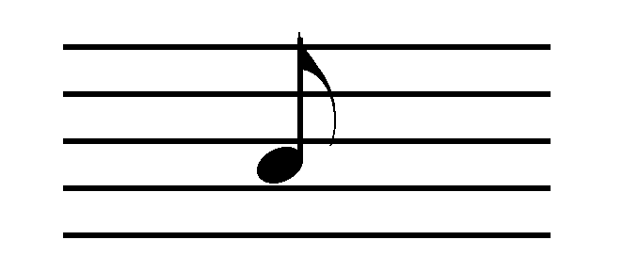
 | Dotted punctum: Long note with time value of 2 beats. Second beat sung softly. | 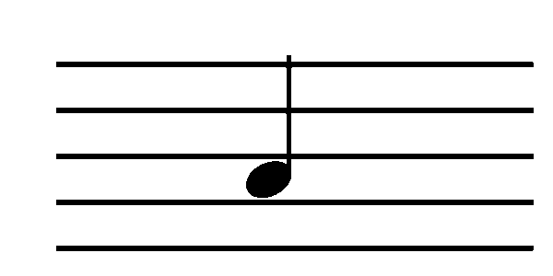
 | Bistropha: Long note with time value of 2 beats. Sung with slight crescendo. | 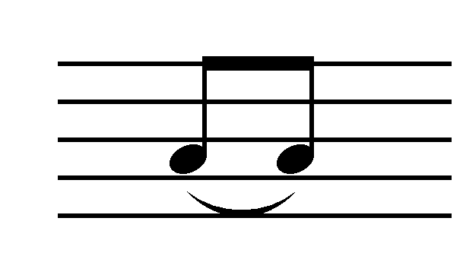
 | Podatus: Bottom note is sung first; followed by the top note which is softened. | 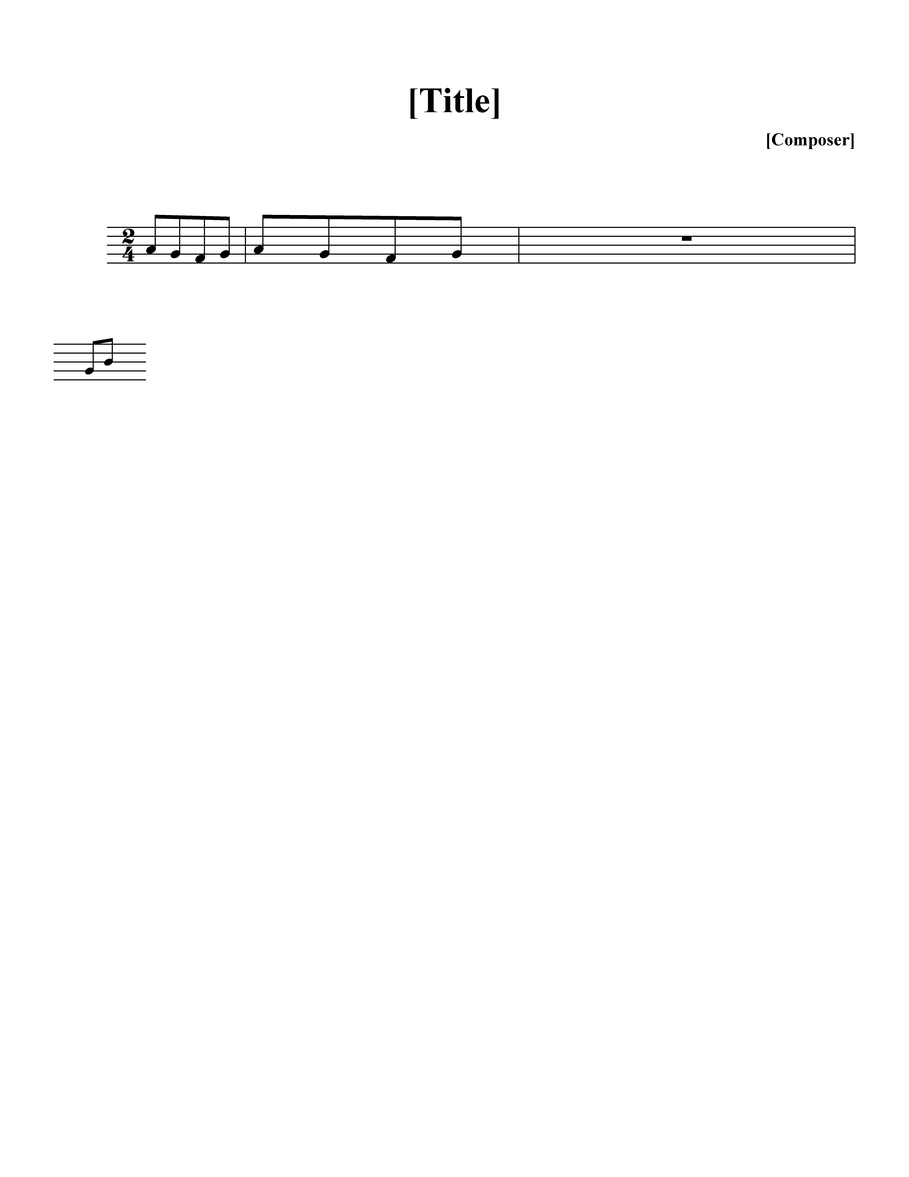
 | Clivis: 2 descending notes; read from left to right. | 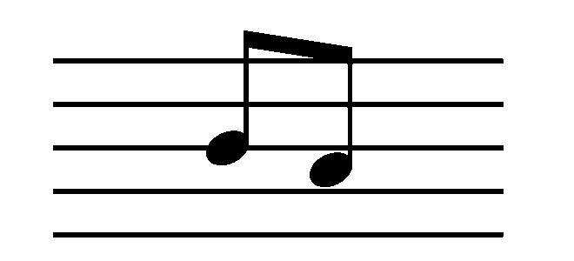
 | Liquescent: Pronounce diphthong (a-u) or a voiced consonant (l, m, n, etc.) on small note that ends syllable.
 | Scandicus: Ascending 3 notes | 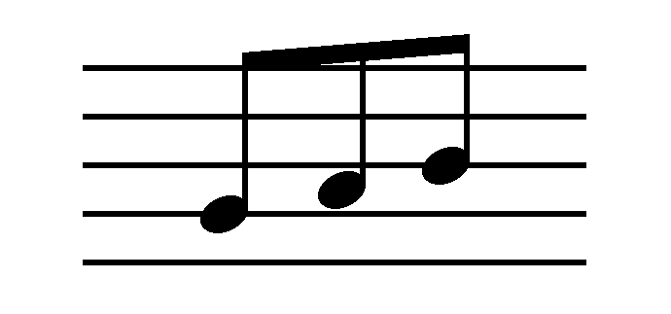
 | Quilisma: Ascending 3 notes noted by jagged line in middle. Middle note sung lightly, moving towards the top note.
 | Torculus: 3 notes, rise to second note, then descends to last note. | 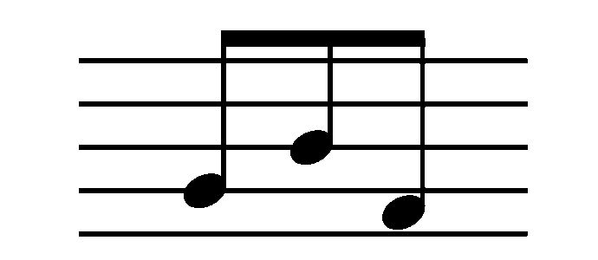
 | Porrectus: 3 notes, middle one lowest. Drawn simply with a line to connect notes.
 | Climacus: Descending neum 3 or more notes. All notes same value (1 beat each). | 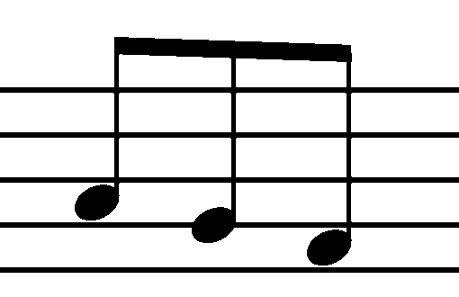
 | Custos: Indicates what the first note will be on the next line.
 | Flat: Remains in effect for as long as the word lasts, up to the next bar line of any kind, or until cancelled by the natural sign (whichever comes first).
 | Mode: Roman numeral indicates mode (the medieval system of scales). There are eight modes in Gregorian chant.
 | Horizontal episema: Horizontal line above or beneath a neum suggesting that the neum be sung expressively. Used in some of the music in this hymnal, but now being removed from Solesmes publications.
 | Vertical episema (ictus) (vertical line beneath a neum): Rhthmic sign indicating the place of count one in binary and tertiary groups of simple beats. Found in some publications; now being removed from current Solesmes publications.

An asterisk (*) within text indicates one singer/choir followed by another singer/choir. Most often used in this booklet to show when the cantor begins the piece, followed by all.

Bars (signs of pause)
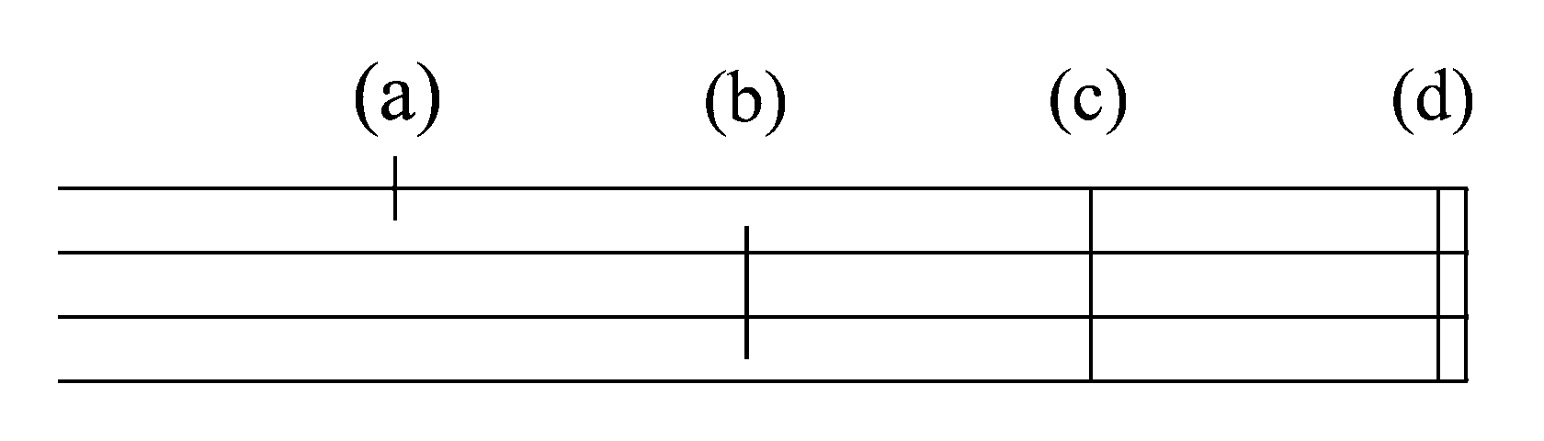

The following are guidelines. The text actually dictates phrasing and determines when choir should take a breath.

(a) Quarter bar: Separates clauses in the text. No breath, unless necessary
(b) Half bar: Separates members of phrase. Almost always implies taking breath.
(c) Full bar: Separates phrases. Slight slowing of movement before bar. Silence of brief duration after bar.* Take breath.
(d) Double bar: Indicates end of a piece or one of its principal parts. Also used to mark place where 2 choirs alternate. Silence of brief duration after bar.* Take breath.

* There may or may not be a rest (1 or 2 count) after a full or double bar. Rules vary. Follow choir director.

Notation at the end of section of text:

bis : Latin word meaning twice. Sing the section twice.
ij : Latin numeration for twice. Sing the section twice.
iij : Latin numeration for three times.

This is often found in Kyrie. Note that the number of repetitions may differ depending upon the Form of the Mass.

