THE MASS IN LATIN

with the setting

MASS VIII (Missa de Angelis)

Abridged version

with the Roman Canon and selected hymns

This booklet was prepared for parish or chapel use (June 2014).

Excerpts from the English translation of The Roman Missal © 2010, International Commission on English in the Liturgy Corporation (ICEL). All rights reserved. This hymnal may reproduced. It should not be sold for profit; it may only be sold for the cost of production. Refer to ICEL copyright policies (www.icelweb.org)

Music and English translation of hymns from Parish Book of Chant (editor Richard Rice) © 2012 used with permission from The Church Music Association of America..

For information contact gregorianchanthymns@gmail.com

THE MASS IN LATIN

WITH THE SETTING

MASS VIII (Missa de Angelis)

TABLE OF CONTENTS

The Order of the Mass

with Mass Setting VIII (Missa de Angelis) 2

Final Antiphons to Our Lady

Salve Regina 34

Alma Redemptoris Mater 35

Ave, Regina caelorum 37

Regina Caeli 38

Sprinkling With Holy Water

Asperges Me 39

Vidi Aquam 40

Hymns 41

Latin Pronunciation Guide 80

Guide to Gregorian Notation 81

References 84

This booklet has been assembled to facilitate congregational participation in the Ordinary Form of the Latin Mass. It is an abridged version for parishes that are reintroducing Latin and therefore contains the Order of the Mass and selected hymns. Only the Ordinary (the unchanging part) of the Mass is included. The Latin Propers (those prayers that change according to the liturgical day when the Mass is celebrated) are contained in the Liber Usualis and The Gregorian Missal for Sundays, notated in Gregorian chant by the Monks of Solesmes.

THE Order of the Mass

When the sacristy bell is rung, please stand.

As the priest enters, all listen to the Introit.

INTROIT

The cantor/choir sings the Introit. Proper Latin texts and English translations are found in The Gregorian Missal.

THE INTRODUCTORY RITE

Priest: In nómine Patris, et Fílii, † et Spíritus Sancti.

In the name of the Father, and of the Son, † and of the Holy Spirit.

All:

A - men

Priest: Dóminus vobíscum.
The Lord be with you.

All: | Et cum spí - ri - tu tuo.  And with your spirit.

THE PENITENTIAL RITE

The Rite of Aspersion (Sprinkling with Holy Water) may replace the Penitential Rite. If so, either the Asperges me or the Vidi aquam is sung (page 39).

Priest: | Fratres, agnoscámus peccáta nostra,  ut apti simus ad sacra mystéria celebránda.
Brethren (brothers and sisters),
let us acknowledge our sins,
and so prepare ourselves to celebrate the sacred mysteries.

All:

I confess to almighty God
and to you, my brothers and sisters,
that I have greatly sinned,
in my thoughts and in my words,
in what I have done and in what I have failed to do,
[And, striking their breast, they say:]

through my fault, through my fault,
through my most grievous fault;
[Then they continue:]

therefore I ask blessed Mary ever-Virgin,
all the Angels and Saints,
and you, my brothers and sisters,
to pray for me to the Lord our God

ABSOLUTION

Priest: | Misereátur nostri omnípotens Deus  et, dimíssis peccátis nostris,  perdúcat nos ad vitam ætérnam.
May almighty God have mercy on us,
forgive us our sins,
and bring us to everlasting life.

All: | Amen.

KYRIE

(bis)

(bis)

Pr. Lord, have mercy. R. Lord, have mercy.
Pr. Christ, have mercy. R. Christ, have mercy.
Pr. Lord, have mercy. R. Lord, have mercy.

(bis = repeat)

GLORIA

Choir and congregation alternate

Priest/cantor: All:

Choir: All:

Glory to God in the highest,
and on earth peace to people of good will.

We praise you,
we bless you,
we adore you,
we glorify you, we give you thanks for your great glory,
Lord God, heavenly King,
O God, almighty Father.

Lord Jesus Christ, Only Begotten Son,
Lord God, Lamb of God, Son of the Father,
you take away the sins of the world, have mercy on us;
you take away the sins of the world, receive our prayer;
you are seated at the right hand of the Father, have mercy on us.
For you alone are the Holy One,
you alone are the Lord,
you alone are the Most High,
Jesus Christ,
with the Holy Spirit, in the glory of God the Father.
Amen.

THE OPENING PRAYER (COLLECT), proper to the day

The prayer concludes … per ómnia sáecula saeculórum.

R. Amen.
LITURGY OF THE WORD

THE FIRST READING

The reader concludes:

The word of the Lord. Thanks be to God.

THE RESPONSORIAL PSALM

The cantor/choir sings antiphon and psalm from the Lectionary or the Gradual. During Eastertide, a first Allelúia is sung in place of the Gradual. Proper Latin texts and English translations are found in The Gregorian Missal.

THE SECOND READING

The reader concludes:

The word of the Lord. Thanks be to God.

(A Sequence may follow the Second Reading)

THE GOSPEL ACCLAMATION

The cantor/choir sings the following, the Allelúia from The Gregorian Missal or an alternative acclamation. In Lent, the Tract may be sung. Proper Latin texts and English translations are found in The Gregorian Missal.

All stand.

Cantor/choir sings and all repeat.

During Lent:

Cantor sings verse. All sing “Misérere mei”
Ps 50: 1- 4

V. Have mercy on me, O God, according to Thy great mercy.
R. Have mercy on me.

2. | Et secúndum multitúdinem miseratiónum tuárum: dele iniquitátem meam.  Miserére mei. |  | And according to the multitude of Thy tender mercies blot out my iniquity.
3. | Amplius lava me ab iniquitáte mea: et a peccáto meo munda me.  Miserére mei. |  | Wash me yet more from my iniquity, and cleanse me from my sin.
4. | Quóniam iniquitátem meam ego cognósco: et peccátum meum contra me est semper.  Miserére mei. |  | For I know my iniquity, and my sin is always before me.

THE GOSPEL

Pr. The Lord be with you.
R. And with your spirit.
Pr. A reading from the holy Gospel according to N.
R. Glory to you, O Lord.

After the reading of the Gospel:

The Gospel of the Lord. Praise to you, Lord Jesus Christ.

All sit.

THE HOMILY

The celebrant delivers the homily.

After the homily, there is a moment of silence for reflection.


THE PROFESSION OF FAITH
The Nicene Creed
Credo III

If spoken, go to page 15

Choir and congregation alternate

Priest: Choir:

All:

Bow

Stand
If spoken:

The Nicene Creed

I believe in one God,
the Father almighty,
maker of heaven and earth,
of all things visible and invisible.

I believe in one Lord Jesus Christ,
the Only Begotten Son of God,
born of the Father before all ages.
God from God, Light from Light,
true God from true God,
begotten, not made, consubstantial with the Father;
through him all things were made.
For us men and for our salvation
he came down from heaven,

[At the words that follow, up to and including “and became man,” all bow.]

and by the Holy Spirit was incarnate of the Virgin Mary,
and became man.

For our sake he was crucified under Pontius Pilate,
he suffered death and was buried,
and rose again on the third day
in accordance with the Scriptures.
He ascended into heaven
and is seated at the right hand of the Father.
He will come again in glory
to judge the living and the dead
and his kingdom will have no end.
I believe in the Holy Spirit, the Lord, the giver of life,
who proceeds from the Father and the Son,
who with the Father and the Son is adored and glorified,
who has spoken through the prophets.

I believe in one, holy, catholic and apostolic Church.
I confess one Baptism for the forgiveness of sins
and I look forward to the resurrection of the dead
and the life of the world to come. Amen.

THE PRAYER OF THE FAITHFUL

The priest, deacon, cantor, or lector sings/says the petitions, each time concluding:

Deacon/Cantor: All:

Lord, have mercy. Lord, have mercy.

Priest: ……through the same Christ our Lord.

All: Amen.

All sit.


THE LITURGY OF THE EUCHARIST

THE OFFERTORY

The gifts of bread, wine and the collection are brought to the altar and given to the priest.

The Offertory Verse or a hymn is sung while the gifts are presented. Proper Latin texts and English translations are found in The Gregorian Missal.

The gifts, the altar, the priest and the congregation are censed.

At the conclusion of the Preparation of the Altar and the Gifts, the priest says:

Priest: | Oráte, fratres:  ut meum ac vestrum sacrifícium  acceptábile fiat apud Deum Patrem omnipoténtem.
Pray, brethren (brothers and sisters),
that my sacrifice and yours
may be acceptable to God, the almighty Father.

All: | Suscípiat Dóminus sacrifícium de mánibus tuis  ad laudem et glóriam nóminis sui,  ad utilitátem quoque nostram  totiúsque Ecclésiæ suæ sanctæ.
May the Lord accept the sacrifice at your hands
for the praise and glory of his name,
for our good
and the good of all his holy Church.

THE PRAYER OVER THE GIFTS

The prayer usually concludes: …. Per Christum Dóminum nostrum.
… through Christ, our Lord.

All: Amen.

THE DIALOGUE AND PREFACE

Pr. The Lord be with you.
R. And with your spirit.
Pr: Lift up your hearts.
R.: We lift them up to the Lord.
Pr. Let us give thanks to the Lord our God.
R. It is right and just.

The celebrant sings or says the Preface after which all sing the Sanctus.

SANCTUS

All:

Holy, Holy, Holy, Lord God of hosts.
Heaven and earth are full of your glory.
Hosanna in the highest.
Blessed is he who comes in the name of the Lord.
Hosanna in the highest.

All kneel.

EUCHARISTIC PRAYER

(The Roman Canon)

[The Priest alone recites:]

Pr. To you, therefore, most merciful Father,
we make humble prayer and petition
through Jesus Christ, your Son, our Lord:
that you accept
and bless these gifts, these offerings,
these holy and unblemished sacrifices,
which we offer you firstly for your holy catholic Church.
Be pleased to grant her peace,
to guard, unite and govern her
throughout the whole world,
together with your servant N. our Pope
and N. our Bishop,∗
and all those who, holding to the truth,
hand on the catholic and apostolic faith.

[Commemoration of the Living.]

Remember, Lord, your servants N. and N.
and all gathered here,
whose faith and devotion are known to you.
For them, we offer you this sacrifice of praise
or they offer it for themselves
and all who are dear to them:
for the redemption of their souls,
in hope of health and well-being,
and paying their homage to you,
the eternal God, living and true.

[Within the Action.]

∗ In communion with those whose memory we venerate,
especially the glorious ever-Virgin Mary,
Mother of our God and Lord, Jesus Christ,*
and blessed Joseph, her Spouse,
your blessed Apostles and Martyrs,
Peter and Paul, Andrew
(James, John,
Thomas, James, Philip,
Bartholomew, Matthew,
Simon and Jude;
Linus, Cletus, Clement, Sixtus,
Cornelius, Cyprian,
Lawrence, Chrysogonus,
John and Paul,
Cosmas and Damian)
and all your Saints;
we ask that through their merits and prayers,
in all things we may be defended
by your protecting help.
(Through Christ our Lord. Amen.)

[With hands extended, the Priest continues:]

Therefore, Lord, we pray:
graciously accept this oblation of our service,
that of your whole family;
order our days in your peace,
and command that we be delivered from eternal damnation
and counted among the flock of those you have chosen.
(Through Christ our Lord. Amen.)

[He joins his hands.]

Be pleased, O God, we pray,
to bless, acknowledge,
and approve this offering in every respect;
make it spiritual and acceptable,
so that it may become for us
the Body and Blood of your most beloved Son,
our Lord Jesus Christ.
On the day before he was to suffer,
he took bread in his holy and venerable hands,
and with eyes raised to heaven
to you, O God, his almighty Father,
giving you thanks, he said the blessing,
broke the bread
and gave it to his disciples, saying:

‘Take this, all of you, and eat of it,
for this is my Body,
which will be given up for you.’

In a similar way, when supper was ended,
he took this precious chalice
in his holy and venerable hands,
and once more giving you thanks, he said the blessing
and gave the chalice to his disciples, saying:

‘Take this, all of you, and drink from it,
for this is the chalice of my Blood,
the Blood of the new and eternal covenant,
which will be poured out for you and for many
for the forgiveness of sins.
do this in memory of me.’

The mystery of faith.

[The people continue, acclaiming:]

We proclaim your Death, O Lord,
and profess your Resurrection

until you come again.

[Then the Priest alone continues:]

Therefore, O Lord,
as we celebrate the memorial of the blessed Passion,
the Resurrection from the dead,
and the glorious Ascension into heaven
of Christ, your Son, our Lord,
we, your servants and your holy people,
offer to your glorious majesty
from the gifts that you have given us,
this pure victim,
this holy victim,
this spotless victim,
the holy Bread of eternal life
and the Chalice of everlasting salvation.
Be pleased to look upon these offerings
with a serene and kindly countenance,
and to accept them,
as once you were pleased to accept
the gifts of your servant Abel the just,
the sacrifice of Abraham, our father in faith,
and the offering of your high priest Melchizedek,
a holy sacrifice, a spotless victim.
In humble prayer we ask you, almighty God:

command that these gifts be borne
by the hands of your holy Angel
to your altar on high
in the sight of your divine majesty,
so that all of us, who through this participation at the altar
receive the most holy Body and Blood of your Son,
may be filled with every grace and heavenly blessing.
(Through Christ our Lord, Amen.)

[Commemoration of the Dead]

Remember also, Lord, your servants N. and N.,
who have gone before us with the sign of faith
and rest in the sleep of peace.
Grant them, O Lord, we pray,
and all who sleep in Christ,
a place of refreshment, light and peace.
(Through Christ our Lord. Amen.)

To us, also, your servants, who though sinners,
hope in your abundant mercies,
graciously grant some share
and fellowship with your holy Apostles and Martyrs:
with John the Baptist, Stephen,
Matthias, Barnabas
(Ignatius, Alexander,
Marcellinus, Peter,
Felicity, Perpetua,
Agatha, Lucy,
Agnes, Cecilia, Anastasia)
and all your Saints;
admit us, we beseech you,
into their company,
not weighing our merits,
but granting us your pardon,
through Christ our Lord.

Through whom you continue to make all these good things, O Lord;
you sanctify them, fill them with life,
bless them, and bestow them upon us.

[The Priest takes the chalice and the paten with the host and, raising both, he alone says:]

Through him, and with him, and in him,
O God, almighty Father,
in the unity of the Holy Spirit,
all glory and honour is yours,
for ever and ever.

The people acclaim: Amen.

All stand.



THE COMMUNION RITE

PATER NOSTER

Priest:

Præcéptis salutáribus móniti,  et divína institutióne formáti,  audémus dícere: |  | At the Saviour’s command  and formed by divine teaching, we dare to say:

All:
Our Father, who art in heaven,
hallowed be thy name;
thy kingdom come, thy will be done
on earth as it is in heaven.
Give us this day our daily bread,
and forgive us our trespasses,
as we forgive those who trespass against us;
and lead us not into temptation,
but deliver us from evil.

Priest: | Líbera nos, quaésumus, Dómine, ab ómnibus malis,  da propítius pacem in diébus nostris,  ut, ope misericórdiæ tuæ adjúti,  et a peccáto simus semper líberi  et ab omni perturbatióne secúri:  exspectántes beátam spem et  advéntum …
Deliver us, Lord, we pray, from every evil,
graciously grant peace in our days,
that by the help of your mercy,
we may be always free from sin
and safe from all distress,
as we await the blessed hope
and the coming of our Saviour, Jesus Christ.

For the kingdom,
the power and the glory are yours
now and for ever.

SIGN OF PEACE

Priest: | Dómine Jesu Christe, qui dixísti Apóstolis tuis:  Pacem relínquo vobis, pacem meam do vobis:  ne respícias peccáta nostra,  sed fidem Ecclésiæ tuæ;  eámque secúndum voluntátem tuam  pacificáre et coadunáre dignéris.  Qui vivus et regnas in saécula saeculórum.
Lord Jesus Christ,
who said to your Apostles:
Peace I leave you, my peace I give you
look not on ours sins,
but on the faith of your Church,
and graciously grant her peace and unity
in accordance with your will.
Who live and reign for ever and ever.

People: | Amen.
Priest: | Pax Dómini sit semper vobíscum.
 |  | The peace of the Lord be with you always.
People: | Et cum spíritu tuo.
 |  | And with your spirit.
Priest: | Offérte vobis pacem.
 |  | Let us offer each other the sign of peace.

The priest gives the sign of peace to those around the altar.

All exchange a sign of peace.

THE BREAKING OF THE BREAD

AGNUS DEI

All:

Lamb of God, you take away the sins of the world,
have mercy on us.
Lamb of God, you take away the sins of the world,
have mercy on us.
Lamb of God, you take away the sins of the world,
grant us peace.

All kneel.

HOLY COMMUNION

At the elevation:

Priest:
Ecce Agnus Dei,
ecce qui tollit peccáta mundi.
Beáti qui ad cenam Agni vocáti sunt.

Behold the Lamb of God,
behold him who takes away the sins of the world.
Blessed are those called to the supper of the Lamb.

People:
Dómine, non sum dignus, ut intres sub tectum meum,
sed tantum dic verbo et sanábitur ánima mea.

Lord, I am not worthy
that you should enter under my roof,
but only say the word,
and my soul shall be healed.

THE COMMUNION ANTIPHON

The antiphon is sung. Proper Latin texts and English translations are found in The Gregorian Missal. A hymn may also be sung during the distribution of Holy Communion.

After the distribution of Holy Communion, there is a period of silence for reflection and thanksgiving.

THE PRAYER AFTER COMMUNION

When the priest stands up, all rise. He sings or says the Prayer after Communion, concluding with:

Priest: | Per Christum Dóminum nostrum.  Through Christ our Lord.
All: | Amen.

CONCLUDING RITES

Priest: | Dóminus vobíscum.  The Lord be with you.
People: | Et cum spíritu tuo.  And with your spirit.
Priest: | Benedícat vos omnípotens Deus,  Pater, et Fílius, † et Spíritus Sanctus.  May almighty God bless you,  the Father, and the Son, † and the Holy Spirit.
People: | Amen.

Priest: People:

Go forth, the Mass is ended. Thanks be to God.

Note: alternative forms of “Ite missa est” on following page.

Alternative Form “Ite Missa est” (Mass VIII)

From Easter Vigil to the Second Sunday of Easter, and on the day of Pentecost:

FINAL ANTIPHONS TO OUR LADY

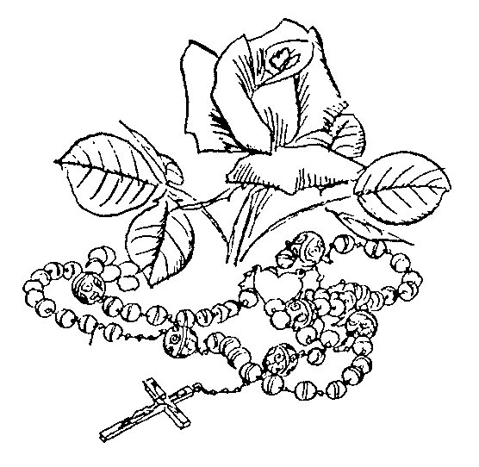

Salve Regina: Ordinary Time pg 34
Alma Redemptoris Mater: Advent – 2 February pg 35
Ave, Regina caelorum: 3 February – Holy Week pg 37
Regina caeli: Easter – Pentecost Sunday pg 38
SALVE REGINA
Ordinary Time

Hail, Holy Queen, Mother of Mercy, our life, our sweetness and our hope! To thee do we cry, poor banished children of Eve; to thee do we send up our sighs, mourning and weeping in this valley of tears. Turn then, O most gracious advocate, thine eyes of mercy toward us, and after this our exile, show unto us the blessed fruit of thy womb, Jesus. O clement, O loving, O sweet Virgin Mary!

Cantor: | Ora pro nobis Sancta Dei Génetrix.  Pray for us, O holy Mother of God.
All: | Ut digni efficiámur promissiónibus Christi.  That we may be worthy of the promises of Christ.

ALMA REDEMPTORIS MATER
Advent - 2 February

Holy Mother of our Redeemer, thou gate leading to heaven and star of the sea; help the falling people who seek to rise, thou who, all nature wondering, didst give birth to thy holy Creator. Virgin always, hearing that Ave from Gabriel’s lips, take pity on us sinners.

During Advent:

Cantor: | Ángelus Dómini nuntiávit Maríae.  The angel of the Lord declared unto Mary.
All: | Et concépit de Spíritu Sancto.  And she conceived of the Holy Spirit.
After Compline on 24 December:

Cantor: | Post partum, Virgo invioláte permansíísti.  After childbirth thou didst remain a virgin.
All: | Dei Génetrix, intercéde pro nobis.  Mother of God, pray for us.

AVE, REGINA CAELORUM
3 February - Holy Week

Hail, Queen of heaven, hail Lady of the angels. Hail root and gate from which the Light of the world was born. Rejoice glorious Virgin, fairest of all. Fare thee well, most beautiful, and pray for us to Christ.

Cantor: | Dignáre me laudáre te Virgo sácrata.  Make me worthy to praise you, O sacred Virgin.
All: | Da mihi virtútem contra hostes tuos.  Give me strength against your enemies.

REGINA CAELI
Easter - Pentecost Sunday

Queen of heaven, rejoice; for he whom thou wast made worthy to bear; has risen as he said; pray for us to God.

Cantor: | Gaude et laetáre Virgo María, Allelúia.  Rejoice and be glad, O Virgin Mary, alleluia.
All: | Qui surréxit Dóminus vere Allelúia.  For the Lord is truly risen, alleluia.

SPRINKLING WITH HOLY WATER

ASPERGES ME
Outside the Easter Season

Sprinkle me with hyssop, O Lord, and I shall be cleansed;
wash me and I shall be whiter than snow.
Ps. Have mercy on me, O God, according to Thy great mercy. Glory be to the Father, and to the Son, and to the Holy Spirit: as it was in the beginning, is now, and ever shall be, world without end. Amen.

VIDI AQUAM
Eastertide

I saw water flowing from the Temple, from its right-hand side, alleluia; and all to who this water came were saved and shall say: Alleluia, alleluia.

HYMNS

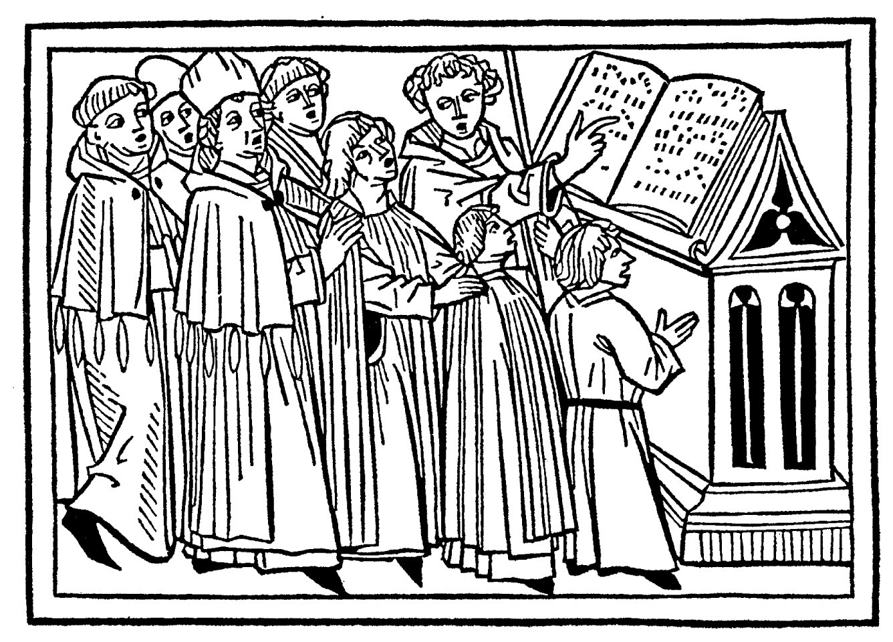

Adoremus in aeternum 48  Adoro te devote 42  Alma Redemptoris 35 Anima Christi 52 Attende Domine 66  Ave Maria 56  Ave maris stella 57  Ave Regina caelorum 37  Ave verum Corpus 53  Concordi laetitia 71  Creator alme 60 | Ecce panis Angelorum 47  Hodie Christus 65  Jesu dulcis memoria 50  O filii et filiae 73  Panis angelicus 46  Parce Domine 68  Puer natus in Bethlehem 62  Regina caeli 38  Salve Regina 34  Ubi caritas 54  Veni Creator Spiritus 77

General ADORO TE DEVOTE

Hymn of St. Thomas Aquinas

Humbly I adore Thee, hidden Godhead, veiled truly under these figures. All my heart I give to Thee, for it all fails in contemplating Thee.

Sight, touch and taste tell me nothing of Thy presence; yet safely I trust what I hear. I believe whatever the Son of God has said; nothing can be more true than the word of Truth itself.

General

On the cross Thy Godhead was hidden; here is hidden Thy manhood too. Yet, I believe and confess both, praying as prayed the good thief.

I do not see Thy wounds like Thomas, yet I confess Thee my God. Grant that I may ever more and more believe in Thee, hope in Thee, love Thee.

General

O memorial of the death of the Lord, living Bread, giving life to man, let me ever live of Thee, ever sweetly taste Thee.

Pious pelican, Jesus Lord, cleanse me, the unclean, by Thy blood, of which one drop is enough to wash the world of all sin.

General

Jesus, Whom now I see veiled, I pray that this may come for which I long so much: that at last, seeing Thee face to face, I may be blessed by the sight of Thy glory. Amen.



General PANIS ANGELICUS

The angelic bread becomes the bread of men; the celestial bread puts an end to figures; O wondrous thing! The poor, the slave and the humble one eats the Lord.

You, Deity triune and one, we urgently ask: thus [please] visit us, as we worship you; along your paths lead us to where we long [to be], to the light which you inhabit.

ECCE PANIS ANGELORUM General

1. | Behold the Bread of Angels, become the food of the pilgrims; truly the bread of the sons, which cannot be thrown to the dogs.
2. | It is pre-signified in types, when Issac is brought to be sacrificed, the Paschal lamb is chosen, manna is given to the fathers.

General

3. | Good shepherd, true bread, Jesus, have mercy on us: feed us, protect us, make us see good things in the land of the living.
4. | You Who know and can do all things, You who feed us mortals here, make us there your table com-panions, coheirs and comrades of the holy citizens.

ADOREMUS IN AETERNUM

General

Let us worship forever the most holy Sacrament. Ps. O praise the Lord, all ye nations: praise Him, all ye people. For His mercy is confirmed upon us: and the truth of the Lord remaineth for ever. Glory be to the Father, and to the Son, and to the Holy Spirit: as it was in the beginning, is now, and ever shall be, world without end. Amen.


General JESU DULCIS MEMORIA
In Honour of the Holy Name of Jesus

How sweet the memory of Jesus, giving joy to true hearts; but beyond honey and all else, is the sweetness of His presence.

Nothing is sung more agreeably, nothing heard more delightfully, nothing thought more sweetly, than Jesus the Son of God.

General

Jesus, hope of penitents, how kind to those who beg, how good to those who seek: but what art Thou to those who find Thee!

Tongue cannot speak, pen cannot write; experience alone can believe, what it is to love Jesus.

Be thou, O Jesus, our joy, Who shall be our future reward: may our glory be in Thee, through everlasting ages.

Vespers Hymn for Feast of the Holy Name of Jesus
Lauds Hymn for Feast of Transfiguration

General ANIMA CHRISTI

General

Soul of Christ, sanctify me: Body of Christ, save me. 2. Blood of Christ, inebriate me: water from the side of Christ, wash me. 3. Passion of Christ, comfort me: O good Jesus, hear me. 4. Within Thy wounds hide me: nor permit me to be separated from Thee. 5. From the foe malign defend me: in the hour of my death call me. 6. And bid me come to Thee: that with Thy Saints I may praise Thee world without end. Amen.

AVE VERUM CORPUS

Hail, true Body, born of Mary the Virgin; truly suffering, sacrificed on the cross for man; from Whose pierced side flowed water and blood. Be to us a foretaste at death’s trial, O sweet Jesus, O loving Jesus, O Jesus Son of Mary.
General UBI CARITAS
Holy Thursday

Where true charity is dwelling, God is present there.

By the love of Christ we have been brought together:
let us find in him our gladness and our pleasure;
may we love him and revere him, God the living,
and in love respect each other with sincere hearts.

Holy Thursday

So when we as one are gathered all together,
let us strive to keep our minds free of division;
may there be an end to malice, strife and quarrels,
and let Christ our God be dwelling here among us.

May your face thus be our vision, bright in glory,
Christ our God, with all the blessed Saints in heaven:
such delight is pure and faultless, joy unbounded,
which endures through countless ages world without end.
Amen.

* Older sources have “Ubi caritas est vera …”

The Blessed Virgin AVE MARIA

Hail Mary, full of grace! the Lord is with thee; blessed art thou among women, and blessed is the fruit of thy womb, Jesus. Holy Mary, Mother of God, pray for us sinners, now and at the hour of our death. Amen.


AVE MARIS STELLA The Blessed Virgin

Hail, star of the sea, kindly Mother of God and ever Virgin, happy gate of heaven.

Receiving that ‘Ave’ from the mouth of Gabriel, establish us in peace, changing the name of ‘Eva’ [Eve]. .

Loosen the chains of the guilty, bring light to the blind, dispel our evils, obtain for us all good things.

The Blessed Virgin

Show thyself a Mother: may he who, being born for us, was willing to be thine, receive [our] prayers through thee.

O singular Virgin, meek above all others, make us free from fault, meek and chaste.

Bestow a pure life, prepare a safe path, that seeing Jesus we may rejoice for ever.

The Blessed Virgin

Be praise to God the Father, glory to the Most High Christ [and] to the Holy Spirit, one honor to the Three.


Advent CREATOR ALME SIDERUM

Propitious Creator of the stars, eternal light of believers, Jesus, Redeemer of all, hearken to the prayers of suppliants.

Who, lest the world should perish through deceits of demons, urged by the vigor of love, becamest the healing of a sickly world.

Who, to expiate the common sin of the world, camest forth a spotless victim from the sanctuary of the Virgin.

Advent

When the power of whose glory and whose name is first sounded, the inhabitants both of heaven and hell are bent on trembling knee.

We beseech thee, Great Judge of the last day, defend us from our enemies with arms of grace from above.

Power, honor, praise, glory to God the Father with the Son, together with the Holy Paraclete, unto ages of ages.

Hymn for Sunday Vespers: Advent 16 December
Christmas PUER NATUS IN BETHLEHEM

Verse:

A child is born in Bethlehem; wherefore Jerusalem rejoices.

Refrain:

In jubilation of heart, let us adore the newborn Christ with a new song.

Verses:

2. Assúmpsit carnem Fílius, allelúia,
Dei Patris altíssimus, allelúia, allelúia In cordis …

The Son hath assumed flesh,
the Most High of God the Father.

3. Per Gabriélem núntium, alleluia,
Virgo concépit Fílium, allelúia, allelúia. In cordis …

Through the messenger Gabriel,
the Virgin conceived a Son.

Christmas

4. Tamquam sponsus de thálamo, allelúia,
Procéssit Matris útero, allelúia, allelúia. In cordis …

Like a bridegroom from his chamber,
he came forth from His Mother’s womb.

5. Hic acet in præsépio, allelúia,
Qui regnat sine término, allelúia, allelúia. In cordis …

He lies in the manger,
Who reigns without end.

6. Et Angelus pastóribus, allelúia,
Revélat quod sit Dóminus, allelúia, allelúia. In cordis …

And the Angel reveals to the shepherds
that this is the Lord.

7. Reges de Saba véniunt, allelúia,
Arum, thus, myrrham ófferunt, allelúia, allelúia. In cordis …

Kings from Saba come,
offering gold, incense, and myrrh.

8. Intrántes domum ínvicem, allelúia,
Novum salútant príncipem, allelúia, allelúia. In cordis …

Entering the house, in turn they
greet the newborn Prince.

9. De Matre natus Vírgine, allelúia:
Qui lumen est de lúmine, allelúia, allelúia. In cordis …

Born of a virgin mother,
Who is Light of Light.

10. Sine serpéntis vúlnere, allelúia,
De nostro venit sánguine, allelúia, allelúia. In cordis …

Without the serpent’s wound,
he came of our blood.

11. In carne nobis símilis, allelúia,
Peccáto sed dissímilis, allelúia, allelúia. In cordis …

Like unto us in flesh,
yet unlike us as to sin.
Christmas

12. Ut rédderet nos hómines, allelúia,
Deo et sibi similes, allelúia, allelúia. In cordis …

In order to render us men
like unto God and Himself.

13. In hoc natáli gáudio, allelúia,
Benedicámus Dómino, allelúia, allelúia. In cordis …

On this joyous natal day,
let us bless the Lord.

14. Laudétur sancta Trínitas, allelúia,
Deo dicámus grátias, allelúia, allelúia. In cordis …

Praised be the Holy Trinity;
let us give thanks to God.

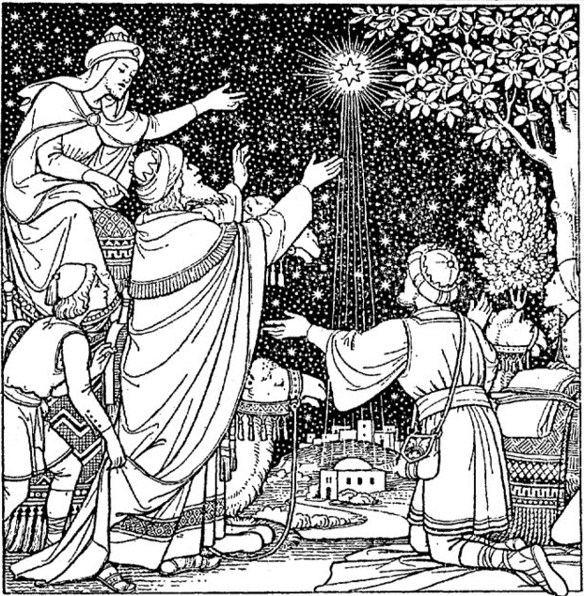
HODIE CHRISTUS NATUS EST Christmas

Today Christ is born; today the Savior appears; today on earth the angels sing, archangels rejoice; today the just exult, saying: Glory to God in the highest, alleluia.

Lent ATTENDE DOMINE

Refrain:

Look down, O Lord, and have mercy, for we have sinned against thee.

To thee, high King, Redeemer of all, weeping we lift our eyes; hear, Christ, the prayers of thy servants.

Verses:

Lent

Right hand of the Father, cornerstone, path of salvation and gate of heaven, cleanse the stain of our sins.

O God, we pray thy majesty, lend thy holy ears to our sighs, mercifully forgive our offenses.

To thee we confess committed sin, with contrite heart we unveil hidden faults; may thy mercy, Redeemer, forgive.

Lent

Seized though innocent, led away unresisting, condemned by false witness in place of the guilty, Christ keep those whom thou hast saved.

PARCE DOMINE

Refrain:

Spare, O Lord, spare Thy people, lest Thou be angry with us forever.

Lent

Verses:

Let us bow down before the avenging wrath; let us weep before the Judge; let us cry forth in prayer of supplication, and all fall prostrate in prayer.

By our sins we have offended Thy clemency, O God; pour out on us thy pardon from on high, Thou Who dost forgive.

Lent

Offering an acceptable time, give streams of tears to wash the sacrifice of our heart, which joyful charity enkindles.

Hear, thou merciful Creator, the tearful prayers poured forth during this holy fast of forty days.

Beloved searcher of hearts, thou knowest the infirmities of men; show pardoning grace to those who return to thee.

CONCORDI LAETITIA Easter
In Honour of Blessed Virgin Mary

Sounds of joy have put to flight all the sadness of the night: now a maid beyond compare hears her praises fill the air: O Virgin Mary!

Who blooms like the lily, with fruitful joy in the risen Lord, clearly seeing her living Son: O Virgin Mary!

Easter

Whom heavenly choirs praise in equal harmony, and we with the heavenly hosts make a new song: O Virgin Mary!

O Queen of virgins, graciously favour our prayers, and after the contest of death, bring the reward of life: O Virgin Mary!

O glorious Trinity, undivided Unity, because of the merits of Mary, save us through the ages: O Virgin Mary!

O FILII ET FILIAE Easter

Refrain:

Verses:

O sons and daughters, the celestial King, the glorious King, from death arose today.

Early on the first day of the week, unto the door of the tomb, came the disciples.

Easter

Mary Magdalene, and Mary of James, and Salome, came to anoint the body.

A white-robed Angel sitting there, foretold unto the women: The Lord is in Galilee.

The Apostle John, quickly outran Peter, and came first to the tomb.

Easter

As the disciples stood together, in their midst stood Christ, and said: Peace be to all of you.

When word reached the Twin that Jesus had risen, he persisted in his doubt.

Behold, Thomas, see my side, see my feet, see my hands, be unbelieving no more.

Easter

When Thomas Christ’s side, his feet, his hands beheld, he proclaimed: Thou art my God.

Blessed are they who have not seen, yet firmly believed; they shall have life eternal.

On this most holy feast, let there be praise and jubilation, and let us bless the Lord.

For these things, let us most humbly, devoutly and dutifully, render our Deo gratias.

VENI CREATOR SPIRITUS Pentecost

Come Creator Spirit, visit the souls of Thy people,
Fill with grace from on high the hearts which Thou hast created.

Thou Who art called the Comforter, gift of the most high God,
Living fountain, fire, love and unction of souls.

Sevenfold in Thy gifts, finger of the Father’s right hand,
Thou promised truly by the Father, giving speech to tongues.

Pentecost

Inflame our senses with Thy light, pour Thy love into our hearts,
Strengthen our weak bodies with lasting power.

Drive far away the enemy, grant peace at all times:
So under Thy guidance may we avoid all evil.

Grant us by Thee to know the Father and to know the Son,
And Thee, Spirit of both, may we always believe.

Pentecost

To God the Father be glory, to the Son Who rose from the dead
And to the Comforter, for all ages. Amen.

LATIN PRONUNCIATION GUIDE

VOWELS:

Note: generally, when two vowels are adjacent, pronounce both letters (eu is “eh –oo”). Exceptions: ae [æ], oe [œ] (both “eh” almost like “ay”)

A | “ah” as in father
AE | “eh” almost like “ay”
E | “eh” as in elf
I | “ee” as in meet
I | between two vowels - like “y” as in yes or Latin alleluia
O | open “oh” as in bought (round lips for “oh” and say “awe”)
OE | “eh” almost like “ay”
U | “oo” as in root
U | before a vowel and after gn or q - like “W” as in quilt or Latin word qui

CONSONANTS:

The pronunciation of Latin consonants is the same as English, with the following exceptions.

C | before a, o, or u - like “k” as in cat
C | before e, i, y, ae, or oe - like “ch” as in church
C | after X and before e, i, y, ae, or oe - like “sh” in shirt or excelsis
CH | “k” as in cat
G | before a, o, or u - like “g” as in golf
G | before e, i, y, ae, or oe - like “g” as in gem
GN | “nyuh”, as in the middle of onion
H | sometimes silent as in honour
J | “y” as in yes
N | before a consonant – like “ng” as in finger
S | between two vowels or preceded by a consonant - like “z”
SC | (or SCH) like “sk” in skunk before a, o, u, or consonant
SC | like “sh” in shirt before e, i, y, ae, or oe
TI | before a vowel, like “tsee”
TH | “t” as in top
Y | “ee” as in candy
Z | “dz” as in maids

A GUIDE TO GREGORIAN NOTATION

Neumes = notes sung on a single syllable

 | Do clef: Indicates where Do is on the staff.
 | Fa clef: Indicates where Fa is on the staff.
 | Punctum: Single note with time value of 1 beat. | 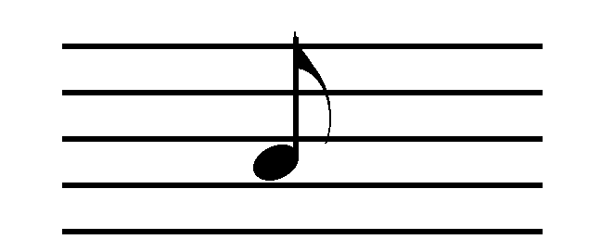
 | Dotted punctum: Long note with time value of 2 beats. Second beat sung softly. | 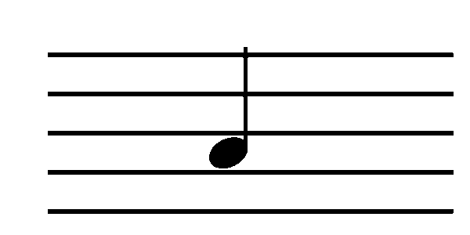
 | Bistropha: Long note with time value of 2 beats. Sung with slight crescendo. | 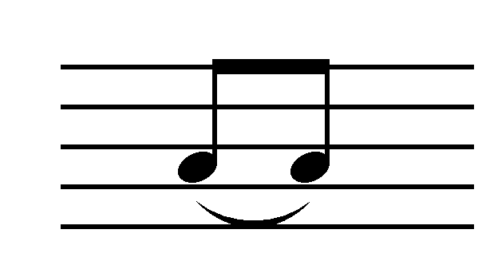
 | Podatus: Bottom note is sung first; followed by the top note which is softened. | 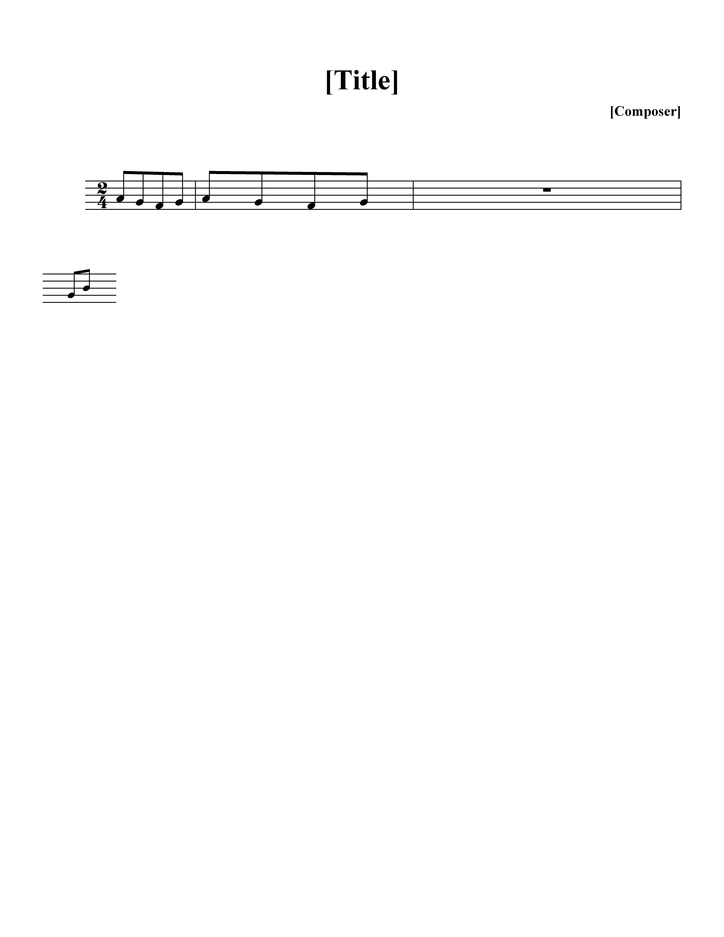
 | Clivis: 2 descending notes; read from left to right. | 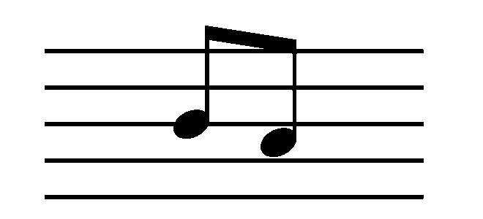
 | Liquescent: Pronounce diphthong (a-u) or a voiced consonant (l, m, n, etc.) on small note that ends syllable.
 | Scandicus: Ascending 3 notes | 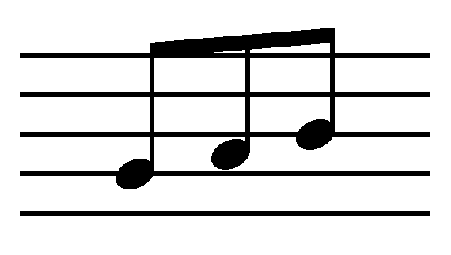
 | Quilisma: Ascending 3 notes noted by jagged line in middle. Middle note sung lightly, moving towards the top note.
 | Torculus: 3 notes, rise to second note, then descends to last note. | 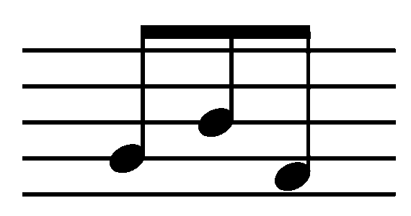
 | Porrectus: 3 notes, middle one lowest. Drawn simply with a line to connect notes. | \
 | Climacus: Descending neum 3 or more notes. All notes same value (1 beat each). | 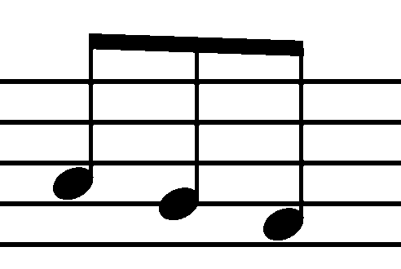
 | Custos: Indicates what the first note will be on the next line.
 | Flat: Remains in effect for as long as the word lasts, up to the next bar line of any kind, or until cancelled by the natural sign (whichever comes first).
 | Mode: Roman numeral indicates mode (the medieval system of scales). There are eight modes in Gregorian chant.
 | Horizontal episema: Horizontal line above or beneath a neum suggesting that the neum be sung expressively. Used in some of the music in this hymnal, but now being removed from Solesmes publications.
 | Vertical episema (ictus) (vertical line beneath a neum): Rhythmic sign indicating the place of count one in binary & tertiary groups of simple beats. Found in some publications; now being removed from current Solesmes publications.

An asterisk (*) within text indicates one singer/choir followed by another singer/choir. Most often used in this booklet to show when the cantor begins the piece, followed by all.

Bars (signs of pause)
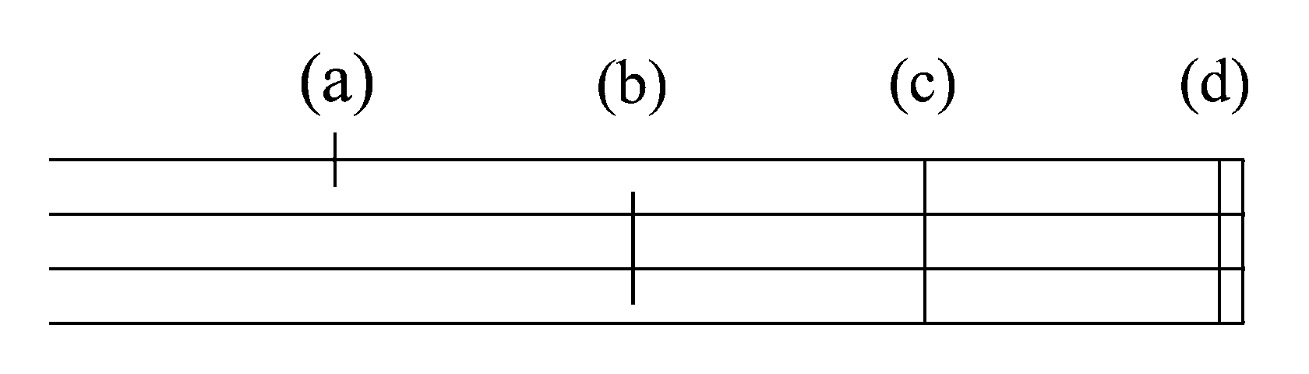

The following are guidelines. The text actually dictates phrasing and determines when choir should take a breath.

(a) Quarter bar: Separates clauses in the text. No breath, unless necessary
(b) Half bar: Separates members of phrase. Almost always implies taking breath.
(c) Full bar: Separates phrases. Slight slowing of movement before bar. Silence of brief duration after bar.* Take breath.
(d) Double bar: Indicates end of a piece or one of its principal parts. Also used to mark place where 2 choirs alternate. Silence of brief duration after bar.* Take breath.

* There may or may not be a rest (1 or 2 count) after a full or
double bar. Rules vary. Follow choir director.

Notation at the end of section of text:

bis : Latin word meaning twice. Sing the section twice.
ij : Latin numeration for twice. Sing the section twice.
iij : Latin numeration for three times.

This is often found in Kyrie. Note that the number of repetitions may differ depending upon the Form of the Mass.

REFERENCES

Musica Sacra. (Church Music Association of America, 2012)
<http://musicasacra.com/>. Contains comprehensive resource including literature and music for download

Richard Rice (ed). The Parish Book of Chant: Expanded Second Edition (Church Music Association of America, Richmond, Virginia, 2012). ISBN 978-0984865291

For further information on-line:

Comprehensive resource including literature and music for download: Musica Sacra www.musicasacra.com

Downloads of mp3 files of chant Ordinaries and Propers. Corpus Christi Watershed. (Mass Ordinaries http://antoinedanielmass.org/kyriale/ )
(Propers http://isaacjogues.org/chants/ )
and http://www.ccwatershed.org/liturgy/

Sources for Music and Translations

The Church Music Association of America (CMAA). All music for Ordinary of the Mass and other hymns are from The CMAA Parish Book of Chant (Richard Rice 2012) CMAA <http://musicasacra.com> with exceptions noted below.

Translations for the CMMA music is also from the CMAA, with the following exceptions:

The International Committee on English in the Liturgy (ICEL): Text in Order of the Mass, Asperges me, Ubi caritas, and the refrain of Vidi aquam:

∗ Mention may be made here of the Coadjutor Bishop, or Auxiliary Bishops.
∗ The text for the beginning of this prayer varies according to the feast or season.

