MUSIC for the MASS

and

BENEDICTION



St. James’s Roman Catholic Church

Spanish Place, London W1

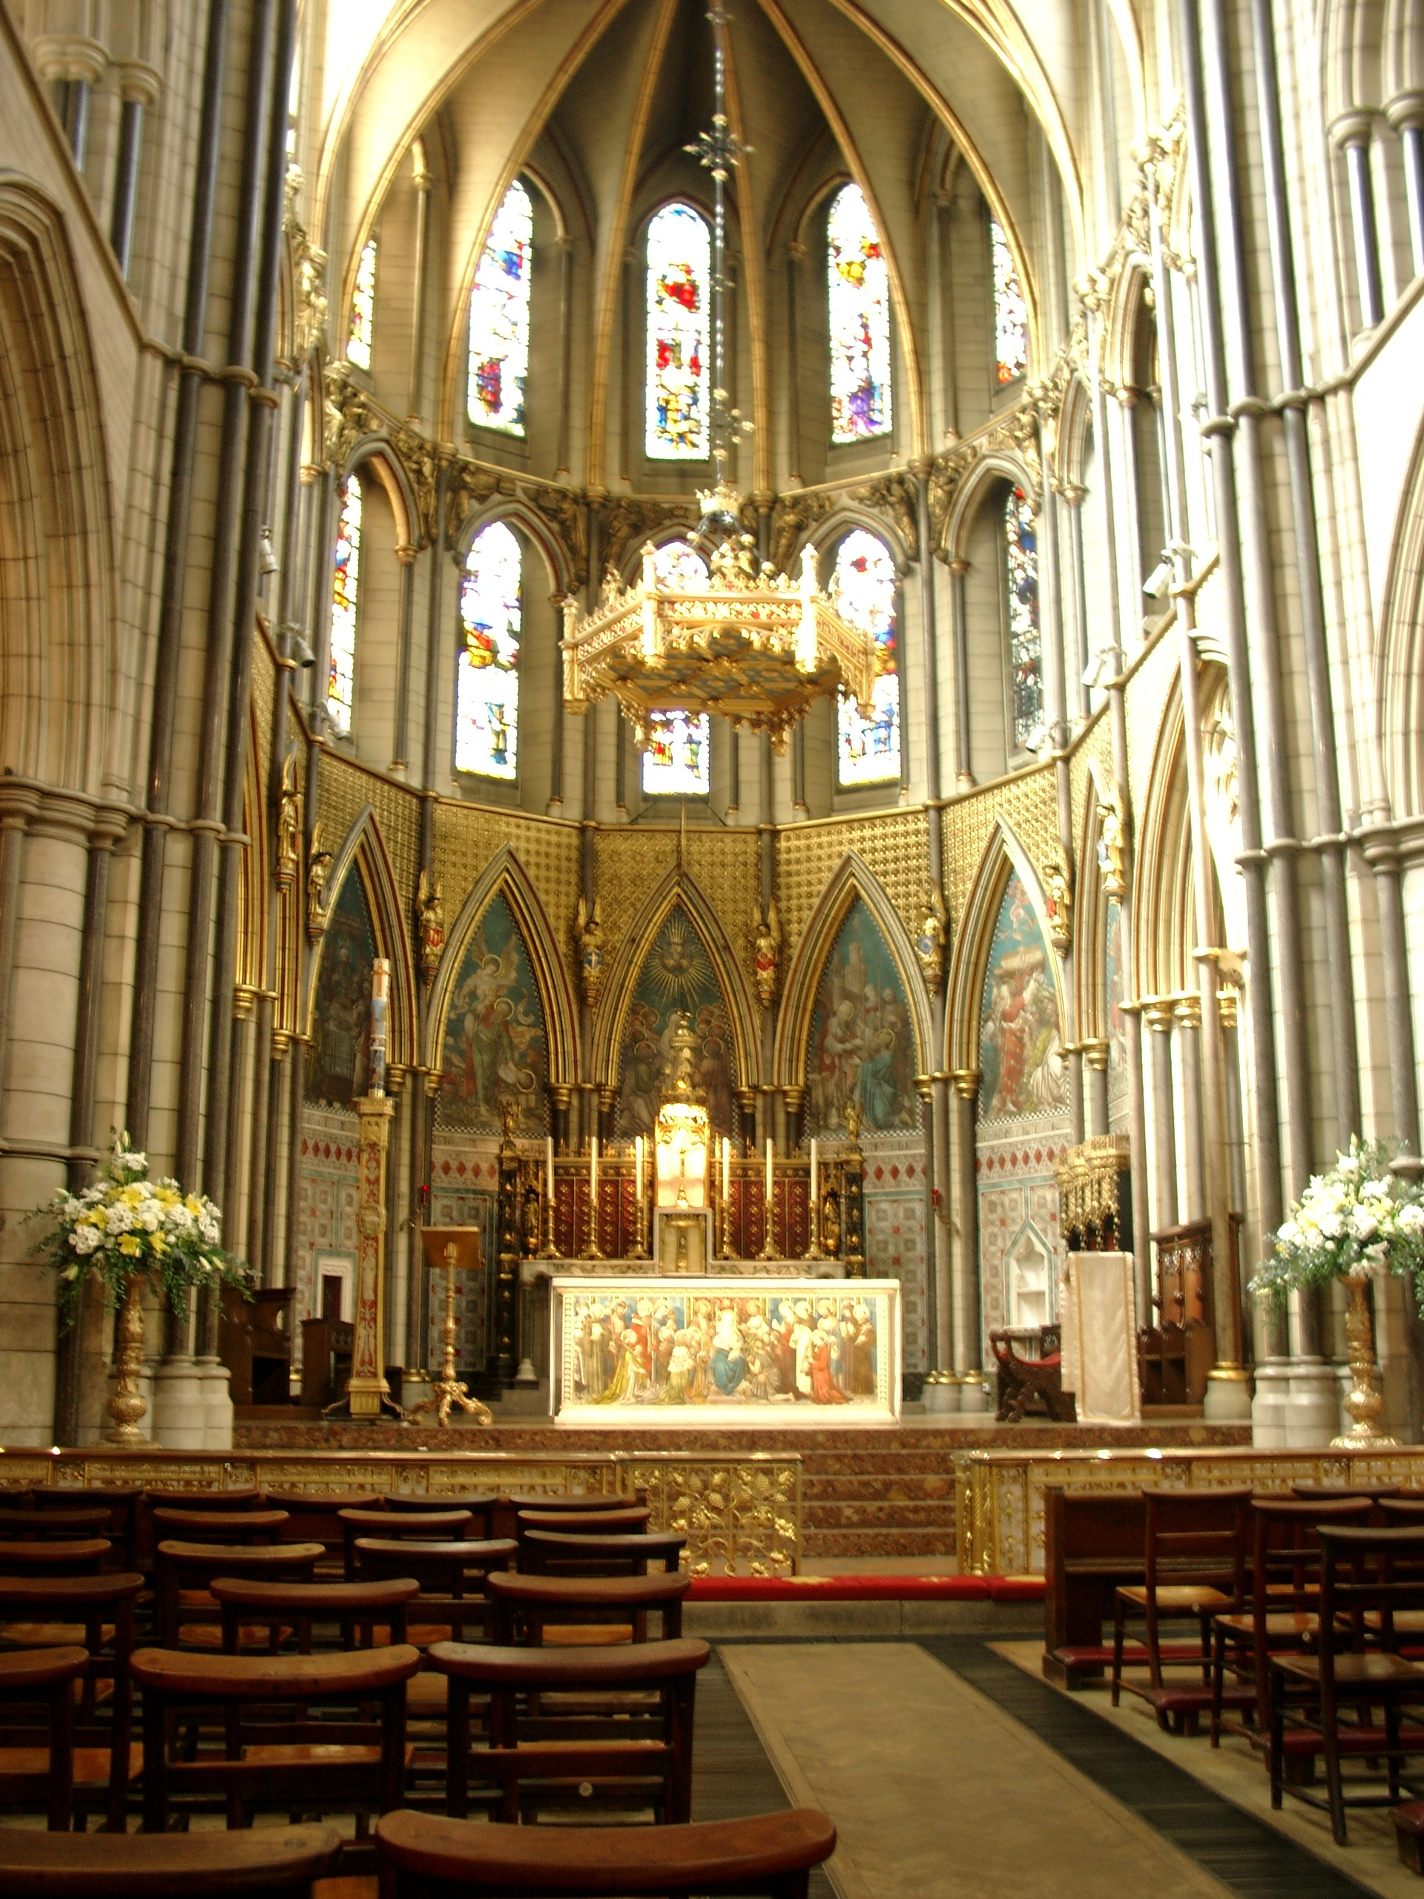

CD: Produced by Roy Emerson and suny by Martina Jelínková and Dan Lambeth.

Recorded at St. James’s Spanish Place.

MUSIC for the MASS

and

BENEDICTION

TABLE OF CONTENTS

The Order of the Mass

with Mass Setting VIII (Missa de Angelis) 2

Final Antiphons to Our Lady

Salve Regína 22

Regína caeli 23

Alma Redemptóris Mater 24

Ave, Regína caelórum 25

Sprinkling With Holy Water

Aspérges Me 26

Vidi Aquam 27

Alternative Mass Settings

Mass I (*Lux et origo*): Easter Season 30

Mass XI (*Orbis factor*): Ordinary Sundays 32

Mass XVII: Sundays in Advent and in Lent 34

Ambrosian Glória 36

Benediction of the Blessed Sacrament 38

References 45

Latin Pronunciation Guide 46

Guide to Gregorian Notation 47

This booklet has been assembled to encourage congregational participation in the Mass. Special thank you to Rev. Christopher Colvin and Dr. Terry Worroll for their support and to the volunteers who created this booklet: Martina Jelínková (cantor), Roy Emerson (recording and CD), Dan Lambeth (cantor), and Candy Bartoldus (booklet). We are also grateful for receiving permission from the International Committee on English in the Liturgy (new English translations) and The Church Music Association of America (music).

THE Order of the Mass

INTROIT

*The cantor/choir sings the Introit. Proper Latin texts and English translations are found in* The Gregorian Missal.

THE INTRODUCTORY RITE

THE PENITENTIAL RITE

*The Rite of Aspersion (Sprinkling with Holy Water) may replace the Penitential Rite. If so, either the* Aspérges m*e or the* Vidi aquam *is sung (page 26).*

CONFITEOR

TRACK 1

*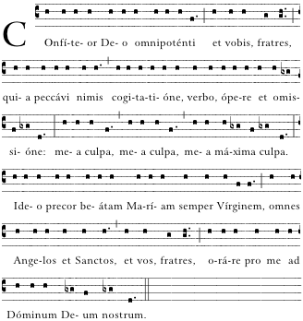*



|  |  |
| --- | --- |
|  | *I confess to almighty God*  *and to you, my brothers and sisters,*  *that I have greatly sinned,*  *in my thoughts and in my words,*  *in what I have done and in what I have failed to do,* |
| [And, striking their breast, they say:] | |
|  | *through my fault, through my fault,*  *through my most grievous fault;* |
| [Then they continue:] | |
|  | *therefore I ask blessed Mary ever-Virgin,*  *all the Angels and Saints,*  *and you, my brothers and sisters,*  *to pray for me to the Lord our God* |

KYRIE (Mass VIII)

TRACK 2

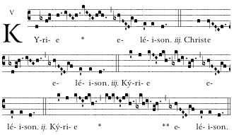

|  |
| --- |
| *Pr. Lord, have mercy. R. Lord, have mercy.*  *Pr. Christ, have mercy. R. Christ, have mercy.*  *Pr. Lord, have mercy. R. Lord, have mercy.* |

GLORIA (Mass VIII)

TRACK 3

*Choir and congregation alternate*

*Priest/cantor: All:*

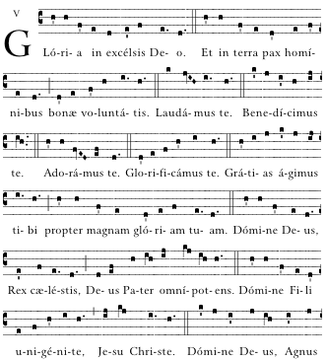

*Choir: All:*





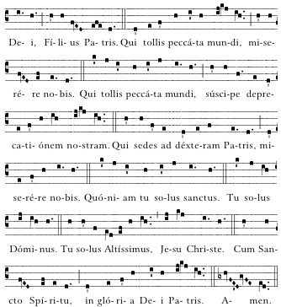



|  |
| --- |
| *Glory to God in the highest,*  *and on earth peace to people of good will.*  *We praise you,*  *we bless you,*  *we adore you,*  *we glorify you, we give you thanks for your great glory,*  *Lord God, heavenly King,*  *O God, almighty Father.*  *Lord Jesus Christ, Only Begotten Son,*  *Lord God, Lamb of God, Son of the Father,*  *you take away the sins of the world, have mercy on us;*  *you take away the sins of the world, receive our prayer;*  *you are seated at the right hand of the Father, have mercy on us.*  *For you alone are the Holy One,*  *you alone are the Lord,*  *you alone are the Most High,*  *Jesus Christ,*  *with the Holy Spirit, in the glory of God the Father.*  *Amen.* |

LITURGY OF THE WORD

THE GOSPEL ACCLAMATION

*The cantor/choir sings the Alleluia from* The Gregorian Missal *or an alternative acclamation. In Lent, the Tract or the following may be sung.*

TRACK 4

*Cantor sings verse. All sing “****Misérere mei****”*

*Ps 50: 1-4*

*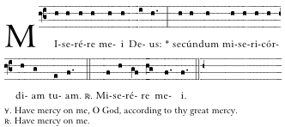*

*V. Have mercy on me, O God, according to Thy great mercy.*

*R. Have mercy on me.*

**

*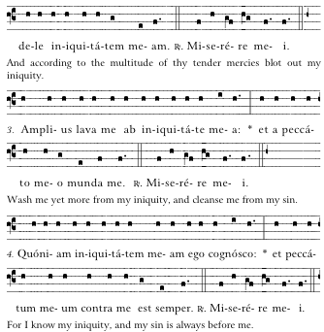*

|  |
| --- |
| *And according to the multitude of thy tender mercies blot out my iniquity.* |

**

|  |
| --- |
| *Wash me yet more from my iniquity, and cleanse me from my sin.* |

**

|  |
| --- |
| *For I know my iniquity, and my sin is always before me.* |



THE GOSPEL

TRACK 5

*Introduction to the Gospel:*

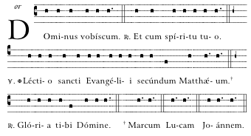

|  |
| --- |
| *Pr. The Lord be with you.*  *R. And with your spirit.*  *Pr. A reading from the holy Gospel according to N.*  *R. Glory to you, O Lord.* |

TRACK 6

*Response after the Gospel:*



|  |
| --- |
| *The Gospel of the Lord. Praise to you, Lord Jesus Christ.* |

THE HOMILY

THE PROFESSION OF FAITH

The Nicene Creed

Credo III

TRACK 7

*Choir and congregation alternate*

*Priest: Choir:*

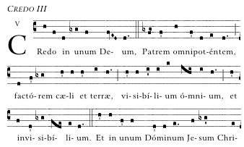

*All:*



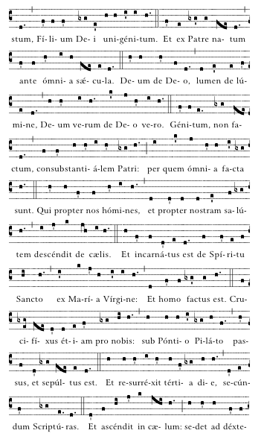



*Bow*

**

*Stand*



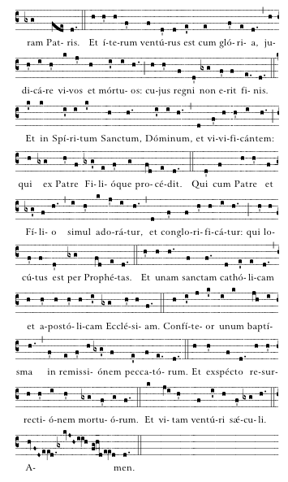





|  |
| --- |
| *The Nicene Creed*  *I believe in one God,*  *the Father almighty,*  *maker of heaven and earth,*  *of all things visible and invisible.*  *I believe in one Lord Jesus Christ,*  *the Only Begotten Son of God,*  *born of the Father before all ages.*  *God from God, Light from Light,*  *true God from true God,*  *begotten, not made, consubstantial with the Father;*  *through him all things were made.*  *For us men and for our salvation*  *he came down from heaven,*  *[At the words that follow, up to and including “and became man,” all bow.]*  *and by the Holy Spirit was incarnate of the Virgin Mary,*  *and became man.*  *For our sake he was crucified under Pontius Pilate,*  *he suffered death and was buried,*  *and rose again on the third day*  *in accordance with the Scriptures.*  *He ascended into heaven*  *and is seated at the right hand of the Father.*  *He will come again in glory*  *to judge the living and the dead*  *and his kingdom will have no end.*  *I believe in the Holy Spirit, the Lord, the giver of life,*  *who proceeds from the Father and the Son,*  *who with the Father and the Son is adored and glorified,*  *who has spoken through the prophets.*  *I believe in one, holy, catholic and apostolic Church.*  *I confess one Baptism for the forgiveness of sins*  *and I look forward to the resurrection of the dead*  *and the life of the world to come. Amen.* |

THE PRAYER OF THE FAITHFUL

TRACK 8

*The bidding prayers are said, each time concluding:*

*Deacon/Cantor: All:*



|  |
| --- |
| *Lord, have mercy. Lord, have mercy.* |

THE LITURGY OF THE EUCHARIST

TRACK 9

THE DIALOGUE AND

PREFACE

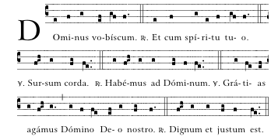

|  |
| --- |
| *Pr. The Lord be with you.*  *R. And with your spirit.*  *Pr: Lift up your hearts.*  *R.: We lift them up to the Lord.*  *Pr. Let us give thanks to the Lord our God.*  *R. It is right and just.* |

SANCTUS (Mass VIII)

TRACK 10

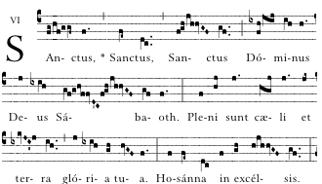

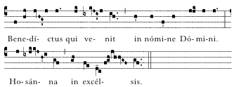

|  |
| --- |
| *Holy, Holy, Holy, Lord God of hosts.*  *Heaven and earth are full of your glory.*  *Hosanna in the highest.*  *Blessed is he who comes in the name of the Lord.*  *Hosanna in the highest.* |

EUCHARISTIC PRAYER

TRACK 11

*The Priest alone says the Eucharistic Prayer and then says:*

Priest: Mystérium fidei:

*The mystery of faith:*

People:

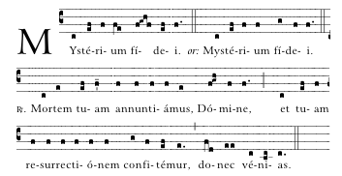

|  |
| --- |
| *We proclaim your Death, O Lord,*  *and profess your Resurrection*  *until you come again.* |



THE COMMUNION RITE

TRACK 12

PATER NOSTER

|  |  |  |  |
| --- | --- | --- | --- |
| Priest: | Præcéptis salutáribus móniti, et divína institutióne formáti, audémus dícere: |  | *At the Saviour’s command*  *and formed by divine teaching,*  *we dare to say:* |

*All:*

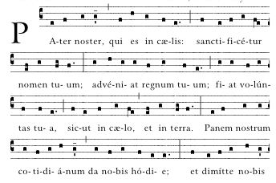

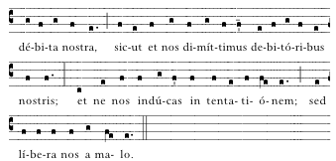

|  |
| --- |
| *Our Father, who art in heaven,*  *hallowed be thy name;*  *thy kingdom come, thy will be done*  *on earth as it is in heaven.*  *Give us this day our daily bread,*  *and forgive us our trespasses,*  *as we forgive those who trespass against us;*  *and lead us not into temptation,*  *but deliver us from evil.* |

|  |  |
| --- | --- |
| Priest: | Líbera nos, quaésumus, Dómine, ab ómnibus malis,  da propítius pacem in diébus nostris,  ut, ope misericórdiæ tuæ adjúti,  et a peccáto simus semper líberi  et ab omni perturbatióne secúri:  exspectántes beátam spem et  advéntum … |

|  |
| --- |
| *Deliver us, Lord, we pray, from every evil,*  *graciously grant peace in our days,*  *that by the help of your mercy,*  *we may be always free from sin*  *and safe from all distress,*  TRACK 13  *as we await the blessed hope*  *and the coming of our Saviour, Jesus Christ.* |

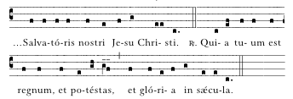

|  |
| --- |
| *For the kingdom,*  *the power and the glory are yours*  *now and for ever.* |

AGNUS DEI (Mass VIII)

TRACK 14

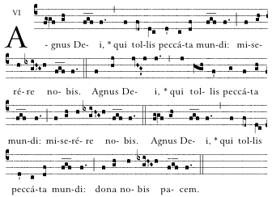

|  |
| --- |
| *Lamb of God, you take away the sins of the world,*  *have mercy on us.*  *Lamb of God, you take away the sins of the world,*  *have mercy on us.*  *Lamb of God, you take away the sins of the world,*  *grant us peace.* |

HOLY COMMUNION

CONCLUDING RITES

TRACK 15

*Common setting :*

*Priest: People:*

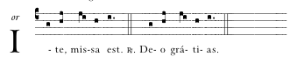

|  |
| --- |
| *Go forth, the Mass is ended. Thanks be to God.* |

TRACK 16

*From Easter Vigil to the Second Sunday of Easter,*

*and on the day of Pentecost :*

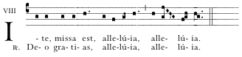

TRACK 17

*Mass VIII :*

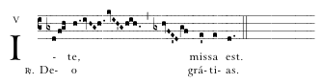

*Alternative Music Settings - pages 31 and 34.*

FINAL ANTIPHONS TO OUR LADY

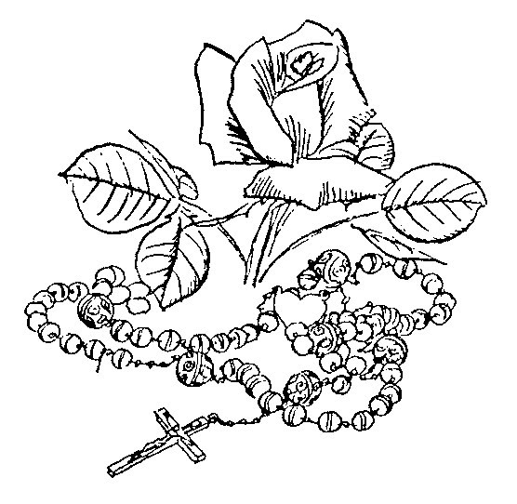

Salve Regína: *Ordinary Time* pg 22

Regína Caeli: *Easter – Pentecost Sunday* pg 23

Alma Redemptóris Mater: *Advent – 2 February* pg 24

Ave, Regina Caelórum: *3 February – Holy Week* pg 25

SALVE REGINA

*Ordinary Time*

TRACK 18

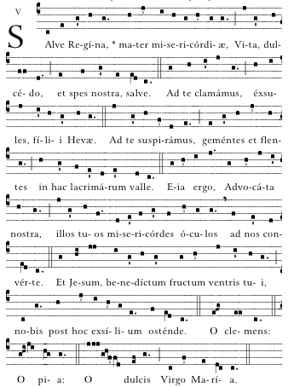



|  |
| --- |
| *Hail, Holy Queen, Mother of Mercy, our life, our sweetness and our hope! To thee do we cry, poor banished children of Eve; to thee do we send up our sighs, mourning and weeping in this valley of tears. Turn then, O most gracious advocate, thine eyes of mercy toward us, and after this our exile, show unto us the blessed fruit of thy womb, Jesus. O clement, O loving, O sweet Virgin Mary!* |

REGINA CAELI

*Easter - Pentecost Sunday*

TRACK 19

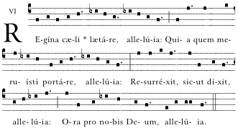

|  |
| --- |
| *Queen of heaven, rejoice; for he whom thou wast made worthy to bear; has risen as he said; pray for us to God.* |

ALMA REDEMPTORIS MATER

*Advent - 2 February*

TRACK 20

TRACK 20

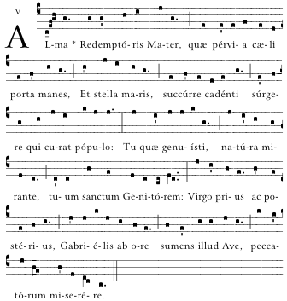

|  |
| --- |
| *Holy Mother of our Redeemer, thou gate leading to heaven and star of the sea; help the falling people who seek to rise, thou who, all nature wondering, didst give birth to thy holy Creator. Virgin always, hearing that Ave from Gabriel’s lips, take pity on us sinners.* |

AVE, REGINA CAELORUM

*3 February - Holy Week*

TRACK 21

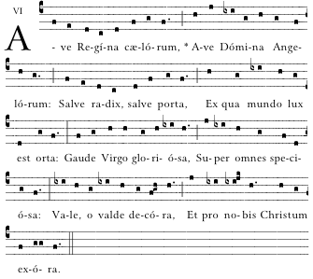

|  |
| --- |
| *Hail, Queen of heaven, hail Lady of the angels. Hail root and gate from which the Light of the world was born. Rejoice glorious Virgin, fairest of all. Fare thee well, most beautiful, and pray for us to Christ.* |

SPRINKLNG WITH HOLY WATER

ASPERGES ME:

*Outside the Easter Season*

TRACK 22

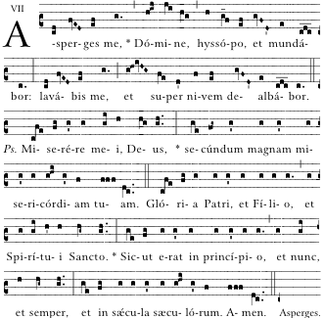

|  |
| --- |
| *Sprinkle me with hyssop, O Lord, and I shall be cleansed;*  *wash me and I shall be whiter than snow.*  *Ps. Have mercy on me, O God, according to Thy great mercy. Glory be to the Father, and to the Son, and to the Holy Spirit: as it was in the beginning, is now, and ever shall be, world without end. Amen.* |

VIDI AQUAM

TRACK 23

*Eastertide*

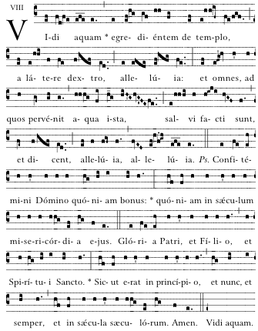

|  |
| --- |
| *I saw water flowing from the Temple, from its right-hand side, alleluia; and all to who this water came were saved and shall say: Alleluia, alleluia.* |

ALTERNATIVE MASS SETTINGS



Mass I (Easter Season) pg 30

Mass XI (Ordinary Sundays) pg 32

Mass XVII (Sundays in Advent and Lent) pg 34

Ambrosian Glória pg 36

*Easter Season*

Mass I - Kyrie

TRACK 24

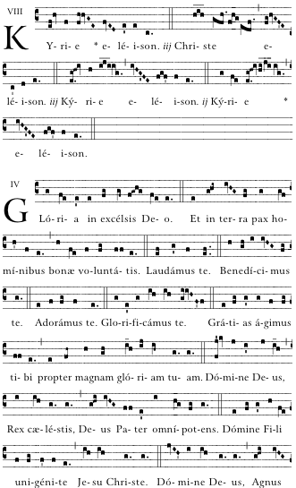

TRACK 25

Mass I - Sanctus

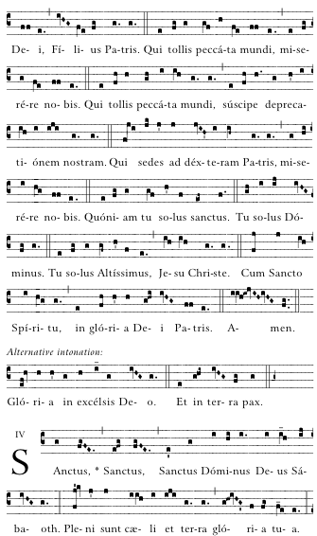

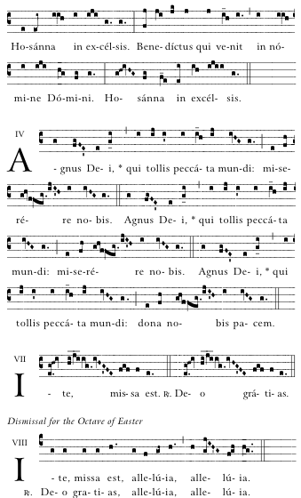

*Easter Season*



TRACK 26

Mass I - Agnus Dei





TRACK 27

Mass I - Ite Missa Est

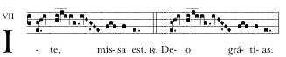

*Ordinary Sundays*

MASS XI - Kyrie

TRACK 28

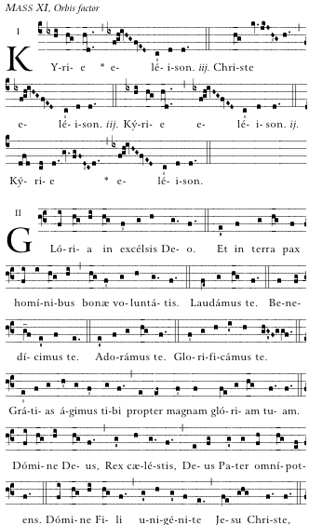

TRACK 29

Mass XI - Sanctus

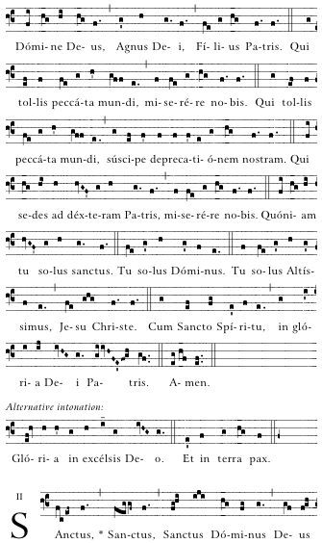

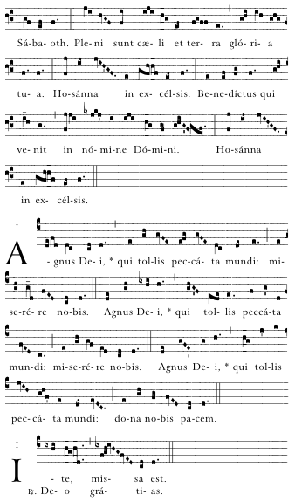

*Ordinary Sundays*



TRACK 30

Mass XI - *Agnus Dei*



*Ordinary Sundays*

TRACK 31

Mass XI - Ite Missa Est

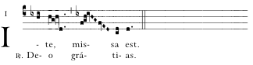

*Sundays in Advent and in Lent*

TRACK 32

MASS XVII - Kyrie

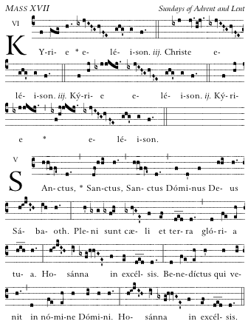

TRACK 33

Mass XVII - Sanctus



*Sundays in Advent and in Lent*



TRACK 34

Mass XVII - Agnus Dei

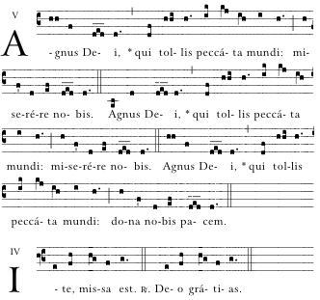

AMBROSIAN GLORIA

TRACK 35

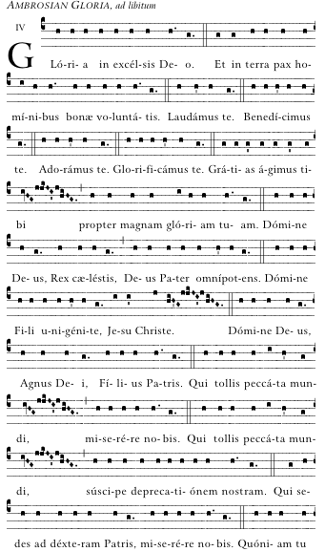



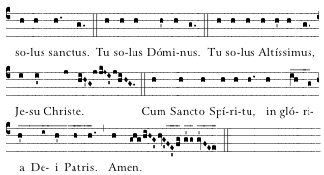

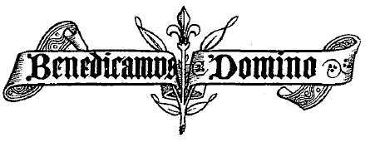

BENEDICTION OF THE BLESSED SACRAMENT

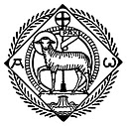

O Salutáris pg 39

Tantum Ergo pg 40

Adóremus in aetérnum pg 42

EXPOSITION

TRACK 36

*Opening Hymn* O SALUTARIS

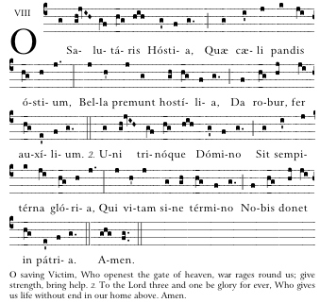

|  |  |
| --- | --- |
| *1.* | *O Saving Victim, opening wide*  *The gate of heav’n to man below;*  *Our foes press on from every side;*  *Thine aid supply, Thy strength bestow.* |
| *2.* | *To thy great name be endless praise,*  *Immortal Godhead, One in Three;*  *O grant us endless length of days*  *In our true native land with Thee. Amen* |

After a period of meditation and reflection the celebrant goes to the altar, genuflects, and kneels. The *Tantum ergo,* is sung:

TANTUM ERGO

TRACK 37

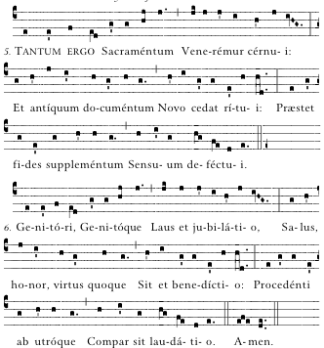

2.

1

|  |  |
| --- | --- |
| *1.* | *Therefore we, before him bending,*  *This great Sacrament revere;*  *Types and shadows have their ending,*  *For the new rite is here;*  *Faith, our outward sense befriending,*  *Makes the inward vision clear.* |
| *2.* | *Glory let us give, and blessing*  *To the Father and the Son;*  *Honour, might, and praise addressing,*  *While eternal ages run;*  *Ever too his love confessing,*  *Who from both, with both is one.*  *Amen.* |

The celebrant will then bless all present with the Eucharist.

|  |  |  |
| --- | --- | --- |
| Priest: | Panem de cælo præstitísti eis. (Allelúia.) | |
|  |  | *You gavest them Bread from heaven. (Alleluia.).* |
| All: | **Omne delectaméntum in se habéntem. (Allelúia.)** | |
|  |  | ***Containing within itself all sweetness. (Alleluia.)*** |
| Priest: | Orémus: Deus, qui nobis sub Sacraménto mirábili passiónis tuæ memóriam reliquísti: *†* tríbue, quaésumus, ita nos córporis et sánguinis tui sacra mystéria venerári; ut redemptiónis tuæ fructum in nobis júgiter sentiámus. Qui vivis et regnas in saécula sæculórum. | |
|  |  | *Let us pray. Lord Jesus Christ, you gave us the Eucharist as the memorial of your suffering and death. May our worship of this sacrament of your body and blood, help us to experience the salvation won for us and the peace of the kingdom, where you live with the Father and the Holy Spirit, one God, for ever and ever.* |
| All: | **Amen.** | |

RESPOSITION

When the priest or deacon has blessed everyone he then replaces the Blessed Sacrament in the tabernacle and genuflects. The Divine Praises is said.

|  |
| --- |
| The Divine Praises  Blessed be God.  Blessed be his Holy Name.  Blessed be Jesus Christ, true God and true Man.  Blessed be the Name of Jesus.  Blessed be his most Sacred Heart.  Blessed be his most Precious Blood.  Blessed be Jesus in the most holy Sacrament of the Altar.  Blessed be the Holy Spirit, the Paraclete.  Blessed be the great Mother of God, Mary most holy.  Blessed be her holy and Immaculate Conception.  Blessed be her glorious Assumption.  Blessed be the name of Mary, Virgin and Mother.  Blessed be St. Joseph, her most chaste spouse.  Blessed be God in his Angels and in his Saints. |

As the celebrant is leaving the *Adoremus in aeternum* is sung.

TRACK 38

ADOREMUS IN AETERNUM

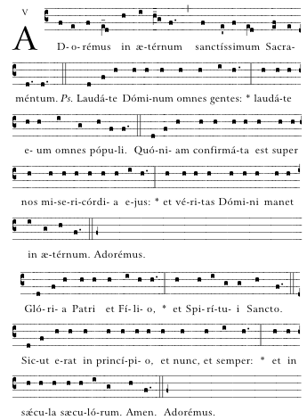



|  |
| --- |
| *Let us worship forever the most holy Sacrament. Ps. O praise the Lord, all ye nations: praise Him, all ye people. For His mercy is confirmed upon us: and the truth of the Lord remaineth for ever. Glory be to the Father, and to the Son, and to the Holy Spirit: as it was in the beginning, is now, and ever shall be, world without end. Amen.* |

REFERENCES

Abbaye Saint-Pierre de Solesmes, *Cantus Selecti.* (Solesmes, 1949). **ISBN 28527401326**

Abbaye Saint-Pierre de Solesmes, *Liber Hymnarius.* (Solesmes, 1998). **ISBN 2852740761**

Abbaye Saint-Pierre de Solesmes, *The Gregorian Missal for Sundays.* (Solesmes, 1990). **ISBN 9782852741331**

Abbatia Sancti Petri de Solesmis, *Liber Cantualis*. (Consociato Internationalis Musica Sacrae, Sablé-Sur-Sarthe, 1978). ISBN [9782852740648](http://www.bookbutler.com/search.html?searchFor=9782852740648&searchBy=isbn&searchIn=fr&sortBy=salesrank&amountIn=gbp&shipTo=gb&zip=&showMore=true&pageNr=1)

Benedictines of Solesmes (eds), *The Liber Usualis with Introduction and Rubrics in English.* (Desclée Company, 1963). ASIN B00ZRX2980

Richard Rice (ed). *The Parish Book of Chant: A New Collection of Gregorian Chant.* (Church Music Association of America, Richmond, Virginia, 2008). ISBN 9780615202105

For further information on-line:

Comprehensive resource including literature and music for download: Musica Sacra <[www.musicasacra.com](http://www.musicasacra.com)>

Downloads of mp3 files of chant Ordinaries and Propers. Corpus Christi Watershed. (Mass Ordinaries <http://antoinedanielmass.org/kyriale/>)

(Propers <http://isaacjoques.org/chants/>) and

<http://www.ccwatershed.org/liturgy/>

Gregorian chant tutorial: Canticum Novum

<http://interletras.com/canticum/Eng/index\_tecnic\_ENG.htm>

LATIN PRONUNCIATION GUIDE

VOWELS:

Note: generally, when two vowels are adjacent, pronounce both letters (eu is “eh –oo”). Exceptions: ae [æ], oe [œ] (both “eh” almost like “ay”)

|  |  |
| --- | --- |
| A | “ah” as in father |
| AE | “eh” almost like “ay” |
| E | “eh” as in elf |
| I | “ee” as in meet |
| I | between two vowels - like “y” as in yes or Latin alleluia |
| O | open “oh” as in bought (round lips for “oh” and say “awe”) |
| OE | “eh” almost like “ay” |
| U | “oo” as in root |
| U | before a vowel and after gn or q - like “W” as in quilt or Latin word qui |

CONSONANTS:

The pronunciation of Latin consonants is the same as English, with the following exceptions.

|  |  |
| --- | --- |
| C | Before a, o, or u - like “k” as in cat |
| C | Before e, i, y, ae, or oe - like “ch” as in church |
| C | after X and before e, i, y, ae, or oe - like “sh” in shirt or excelsis |
| CH | “k” as in cat |
| G | Before a, o, or u - like “g” as in golf |
| G | Before e, i, y, ae, or oe - like “g” as in gem |
| GN | “nyuh”, as in the middle of onion |
| H | sometimes silent as in honour |
| J | “y” as in yes |
| N | Before a consonant – like “ng” as in finger |
| S | between two vowels or preceded by a consonant - like “z” |
| SC | (or SCH) like “sk” in skunk before a, o, u, or consonant |
| SC | like “sh” in shirt before e, i, y, ae, or oe |
| TI | before a vowel, like “tsee” |
| TH | “t” as in top |
| Y | “ee” as in candy |
| Z | “dz” as in maids |

A GUIDE TO GREGORIAN NOTATION

Neumes = notes sung on a single syllable

|  |  |  |
| --- | --- | --- |
| Clef - Do 12_27_10 TIFF.tif | Do clef: Indicates where Do is on the staff. | |
| Clef - FA. 12_27_10 TIFF.tif | Fa clef: Indicates where Fa is on the staff. | |
| Punctum 12_27_10 TIFF.tif | Punctum: Single note with time value of 1 beat. | Punctum standard TIFF 01_17_08 |
| Dotted Punctum 12_27_10 TIFF.tif | Dotted punctum: Long note with time value of 2 beats. Second beat sung softly. | Dotted punctum standard 05_31_10 TIFF |
| Bistropha 03_25_10 TIFF.tif | Bistropha: Long note with time value of 2 beats. Sung with slight crescendo. | Punctum dotted standard TIFF 01_17_08 |
| Podatus 12_27_10 TIFF.tif | Podatus: Bottom note is sung first; followed by the top note which is softened. | Podatus standard TIFF 01_21_08 |
| Clivas 12_27_10 TIFF.tif | Clivas: 2 descending notes; read from left to right. | Clivas standard 03_25_10 |
| Liquescent TIFF 01_21_08 | Liquescent: Pronounce diphthong (a-u) or a voiced consonant (l, m, n, etc.) on small note that ends syllable. | Podatus standard TIFF 01_21_08 |
| Quilisama 12_26_10 TIFF.tif | Quilisma: Ascending 3 notes noted by jagged line in middle. | Quilisma standard TIFF 01_21_08 |
| Torculus 12_28_10 TIFF.tif | Torculus: 3 notes, rise to second note, then descends to last note. | Torculus standard 02_20_08 TIFF |
| Porrectus 12_27_10 TIFF.tif | Porrectus: 3 notes, middle one lowest. Drawn simply with a line to connect notes. | Porrectus standard 12_29_10 TIFF.tif |
| Climacus 12_29_10 TIFF.tif | Climacus: Descending neum 3 or more notes. All notes same value (1 beat each). | Climacus standard 06_08_10 TIFF |
| Custos 12_29_10 TIFF.tif | Custos: Indicates what the first note will be on the next line. | |
| Flat 12_29_10 TIFF.tif | Flat: Remains in effect for as long as the word lasts, up to the next bar line of any kind, or until cancelled by the natural sign (whichever comes first). | |
| Mode 12_20_10 TIFF.tif | Mode: Roman numeral indicates mode (the medieval system of scales). There are eight modes in Gregorian chant. | |

An asterisk (\*) within text indicates one cantor/choir followed by another cantor/choir. Most often used in this booklet to show when the cantor begins the piece, followed by all.

Bars (signs of pause)

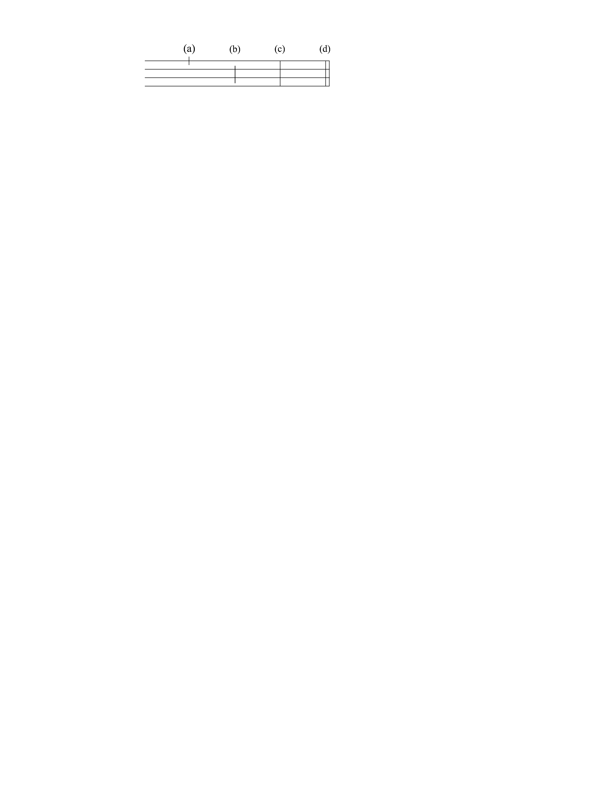

(a) Quarter bar: Separates clauses in the text. No breath, unless necessary

(b) Half bar: Separates members of phrase. Almost always implies taking breath. Do not add extra beat in rhythm. If breath must be taken, take value off of the note before the bar.

(c) Full bar: Separates phrases. Slight slowing of movement before bar. Silence of brief duration after bar. \* Must take breath.

(d) Double bar: Indicates end of a piece or one of its principal parts. Also used to mark place where 2 choirs alternate. Silence of brief duration after bar.\* Must take breath.

|  |
| --- |
| \* There may or may not be a rest (1 or 2 count) after a full or double bar. Rules vary. Follow choir director. In general there is silence of one count placed after the bar if the new phrase begins on the up-pulse, and a silence of 2 counts if the new phrase begins on a down-pulse. |

Notation at the end of section of text:

*bis* : Latin word meaning twice. Sing the section twice.

*ij* : Latin numeration for twice. Sing the section twice.

*iij* : Latin numeration for three times.

This is often found in Kyrie. Note that the number of repetitions may differ depending upon the Form of the Mass.

INDEX OF CHANTS

*Page numbers*

|  |  |
| --- | --- |
| Adóremus in aetérnum 42  Agnus Dei (*Mass I*) 31  Agnus Dei (*Mass VIII*) 19  Agnus Dei (*Mass XI*) 33  Agnus Dei (*Mass XVII*) 35  Alma Redemptóris Mater 24  Aspérges me 26  Ave Regína caelórum 25  Confíteor Deo 2  Credo III 10  Dóminus vobíscum (*Gospel*) 9  Dóminus vobíscum (*Preface*) 14  Glória (*Ambrosian*) 36  Glória (*Mass VIII*) 4  Ite, missa est 20  Ite, missa est (*Easter Vigil*) 20  Ite, missa est (*Mass I*) 31  Ite, missa est (*Mass VIII*) 20  Ite, missa est (*Mass XI*) 34  Kyrie (*Mass I*) 30  Kyrie (*Mass VIII*) 4  Kyrie (*Mass XI*) 32 | Kyrie (*Mass XVII*) 34  Kyrie (*Prayer of Faithful*) 14  Mass I (*Lux et origo)* 30  Mass VIII (*De angelis*) *starts* 4  Mass XI (*Orbis factor)* 32  Mass XVII 34  Miserére mei, *Gospel Accl.* 7  Mortem tuam, *Mem. Accl.* 16  O Salutáris 39  Pater noster 17  Preface Dialogue 14  Quia tuum (*after Pater noster*) 18  Regína caeli 23  Salve Regína 22  Sanctus (*Mass I*) 30  Sanctus (*Mass VIII*) 15  Sanctus (*Mass XI*) 32  Sanctus (*Mass XVII*) 34  Tantum ergo 40  Verbum Dómini (*after Gospel*) 9  Vidi aquam 27 |

|  |
| --- |
| This booklet was prepared for parish use (May 2012).  Excerpts from the English translation of *The Roman Missal* © 2010, International Commission on English in the Liturgy Corporation (ICEL). All rights reserved.  Music and English translation of hymns from *Parish Book of Chant* (Richard Rice) © 2008 used with permission from The Church Music Association of America.  We acknowledge the assistance of the Liturgy Office of the Catholic Bishops’ Conference of England and Wales in the preparation of this booklet.  Fr. Christopher Colven  St James's Roman Catholic Church  Spanish Place  22 George Street  London  W1U 3QY  Tel: 020 7935 0943  Email: [spanishplace@hemscott.net](mailto:spanishplace@hemscott.net) |